**Black Box Testing**

**Gameplay and word translation testing**

|  |  |  |  |  |  |  |  |
| --- | --- | --- | --- | --- | --- | --- | --- |
| **Test Number** | **Settings** | **Purpose of Test** | **Output** | **Input** | **Expected Result** | **Actual Result** | **Comments** |
| **1** | **Spanish, easy difficulty, Common Nouns, easy words, from Foreign to English format.** | To test a sample combination of settings, and see if they work for a single word | casa | house | "Correct answer!" | Evidence 1 | Actual result was as expected, and all words worked (evidence only shown for one) |
| **2** | **Dutch, medium difficulty, Common Verbs, medium words, from Foreign to English format.** | To test a sample combination of settings, and see if they work for a single word halfway through the list | slapen | bed | "Incorrect answer" | Evidence 2 | Actual result was as expected, and all words worked (evidence only shown for one) |
| **3** | **German, hard difficulty, Family, Word Set 1, from Foreign to English format.** | To test a sample combination of settings, and see if they work for a single word at the end of the list | großvater | ground | “Incorrect Answer” | Evidence 3 | Actual result was as expected, and all words worked (evidence only shown for one) |
| **4** | **Finnish, easy difficulty, Phrases, Set 2, from Foreign to English format.** | To test a sample combination of settings, and see if they work for a single word with unusual input | kuinkapaljon on- | ?##%$ | "Incorrect Answer" | Evidence 4 | Actual result was as expected, and all words worked (evidence only shown for one) |
| **5** | **Italian, medium difficulty, Activities, All Words, from English to Foreign format.** | To test a sample combination of settings, and see if they work for a single word in all caps | walking | CAMMINARE | "correct answer" | Evidence 5 | Actual result was as expected, and all words worked (evidence only shown for one) |
| **6** | **Portuguese, hard difficulty, Pronouns, all words, from English to Foreign format.** | To test a sample combination of settings, and see if they work for a single word | you | voce | "Correct answer!" | Evidence 6 | Actual result was not as expected. The program does not accept unaccented equivalents of accented letters, making the English-Foreign format impossible to complete without the strictly required characters. |
| **7** | **Turkish, easy difficulty, Colours, all words, from Foreign to English format.** | To test a sample combination of settings, and see if they work for a single word | kahverengi | brown | "Correct Answer!" | Evidence 7 | Actual result was not as expected, as the suggested answer UI was incorrect (claiming that kahverengi meant blue, instead of brown). This suggests an error within the hard-coded translation to begin with.**This translation error was then fixed, along with other errors highlighted by a similar cause.** |

**UI and Menu Navigation testing**

|  |  |  |  |  |
| --- | --- | --- | --- | --- |
| **Test Number** | **What is being tested?** | **Expected Result** | **Actual Result** | **Comments** |
| **8** | **Language Selection** | -The frame transition animation should occur  -The frame should change to Game Selection  -The chosen language should be set | Evidence 8 | The Actual Result was the same as the Expected Result |
| **9** | **Game Selection** | -The frame transition animation should occur  -The frame should change to the correct Settings screen  -The correct game type should be set | Evidence 9 | The Actual Result was the same as the Expected Result |
| **10** | **Back Button** | -The frame transition animation should occur  -The frame should change to Game Selection if used from settings...  -...and change to Language Selection if used from the Game Selection | Evidence 10 | The animation cut out halfway through, as the frame changed, but apart from that everything worked fine.  When going back from the settings, and then from the game selection to the language selection, the frame does not change. |
| **11** | **Translation Menu Button** | -The translation screen should appear  -The player must not be able to interact with the game UI  -A list of every English word in the database will be displayed  -The user should be able to translate any one of those words from and to any other language  -An error should notify the user if a word cannot be translated or if it is not in the database | Evidence 11 | The Actual Result was the same as the Expected Result |
| **12** | **Return from Translation Menu** | -Returns the user to whichever screen they were previously at by disappearing the translation menu | Evidence 12 | The Actual Result was the same as the Expected Result |
| **13** | **Play Game Button** | -The frame transition animation should occur  -The frame should change to the correct game screen  -All chosen settings should be in place | Evidence 13 | The Actual Result was the same as the Expected Result |
| **14** | **Subcategory Combo box detection** | -The corresponding subcategory combo box should appear and be enabled, depending on the size of category previously chosen  -The comboBox must be disabled by default  -The comboBox must become disabled once more if no category is selected | Evidence 14 | The Actual Result was the same as the Expected Result |
| **15** | **Pause** | -The translation screen should appear  -The player must not be able to interact with the game UI  -Three buttons should be on the screen  -The timer, if there is one for the game, must be stopped | Evidence 15 | The Actual Result was the same as the Expected Result |
| **16** | **Skip Question,** | -No scoring should take place, either positive or negative  -The next word should be displayed on screen  -The game must end if no more words remain  -The round number should increase, as well as the score, should the answer be correct | Evidence 16 | The Actual Result was the same as the Expected Result |
| **17** | **Answer (with the enter key)** | -The player must be scored on whether or not the answer was correct  -UI response should accurately notify them of whether or not the answer was correct. This is shown both by the words appearing above the answer, as well as the tick/X-mark next to the input text.  -If the answer was incorrect, the correct answer must be shown  -The next word should be displayed on screen  -The game must end if no more words remain  -The round number should increase, as well as the score, should the answer be correct | Evidence 17 | The Actual Result was the same as the Expected Result |
| **18** | **Answer (with the onscreen button)** | -The player must be scored on whether or not the answer was correct  -UI response should accurately notify them of whether or not the answer was correct. This is shown both by the words appearing above the answer, as well as the tick/X-mark next to the input text.  -If the answer was incorrect, the correct answer must be shown  -The next word should be displayed on screen  -The game must end if no more words remain  -The round number should increase, as well as the score, should the answer be correct | Evidence 18 | The Actual Result was the same as the Expected Result. However, "hermoso" is the incorrect word for "girl". The correct word would be "chica". |
| **19** | **Replay** | -The frame transition animation should occur  -Should replay the game they were previously playing with the same settings | Evidence 19 | The Actual Result was the same as the Expected Result |
| **20** | **New Game** | -The frame transition animation should occur  -Returns the user to the Game Selection screen | Evidence 20 | The Actual Result was the same as the Expected Result |
| **21** | **Return from Pause Menu** | -Returns the user to their game by disappearing the pause menu  -Timer must continue if previously present prior to pausing | Evidence 21 | The Actual Result was the same as the Expected Result |
| **22** | **Return to Menu from Pause** | -The frame transition animation should occur  -The frame should change to Game selection | Evidence 22 | The Actual Result was the same as the Expected Result |
| **23** | **Restart game from Pause** | -Returns the user to their game by disappearing the pause menu  -Words and scores and time limit are reset.  -Timer must continue if previously present prior to pausing | Evidence 23 | The Actual Result was the same as the Expected Result |

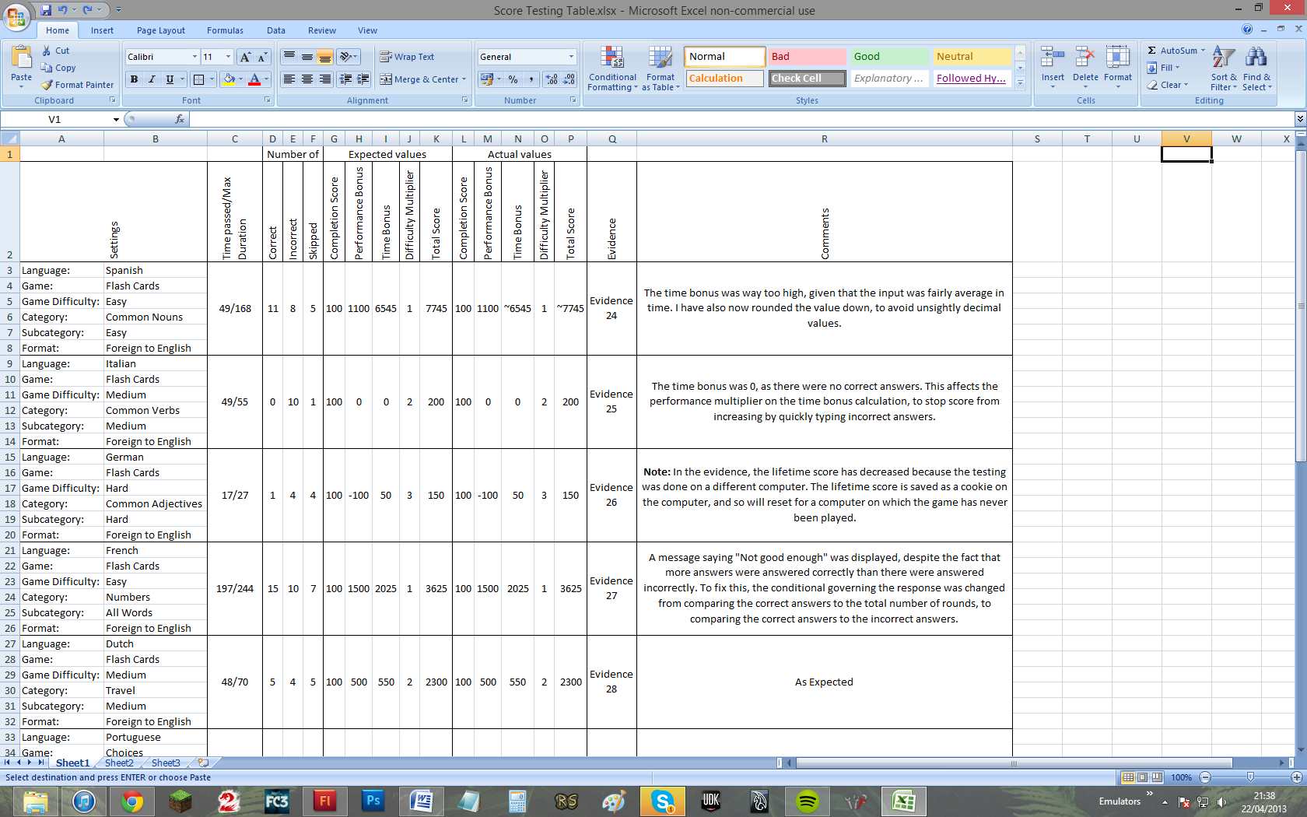

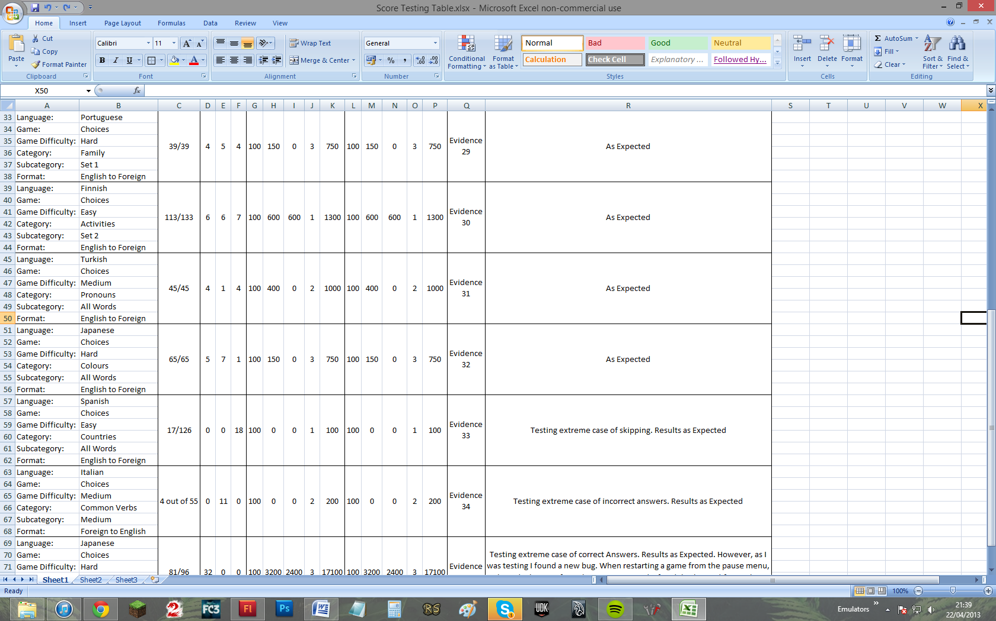

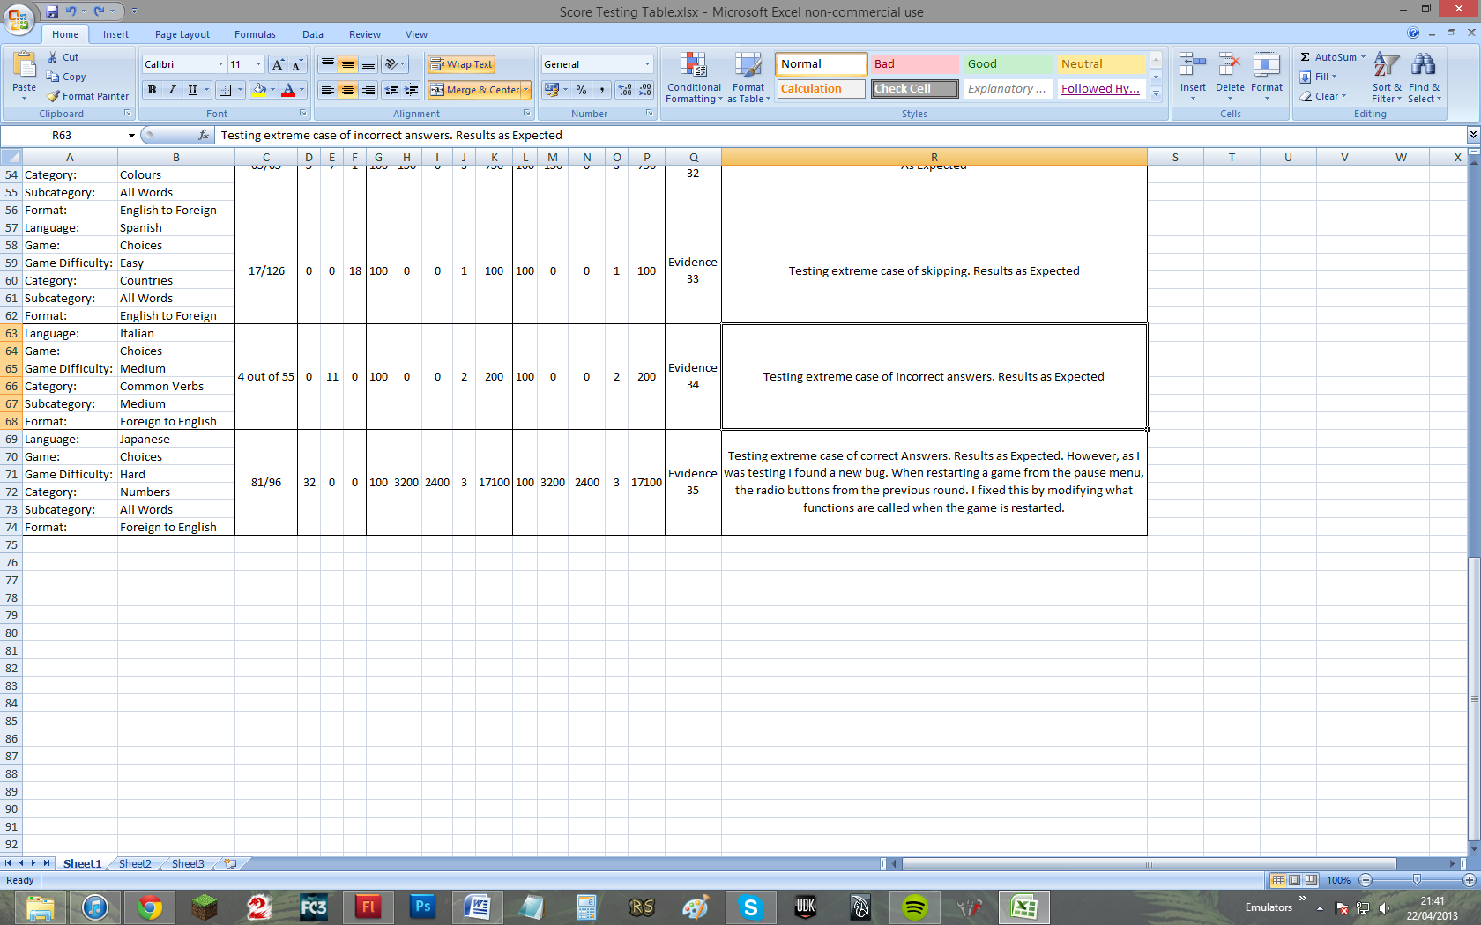

Evidence 1:

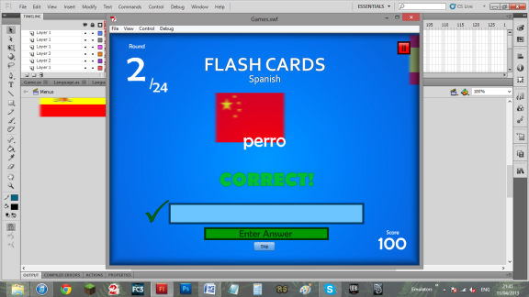

Evidence 2:

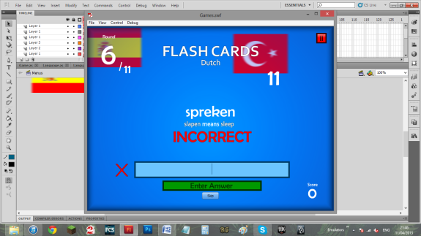

Evidence 3:

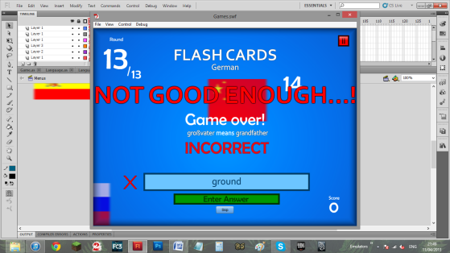

And, once ending:

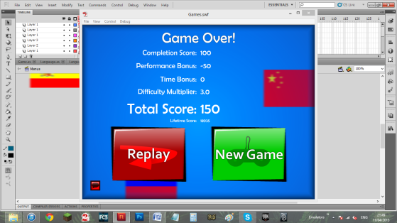

Evidence 4:

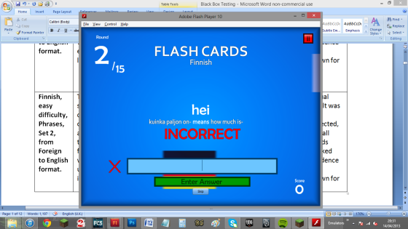

Evidence 5:

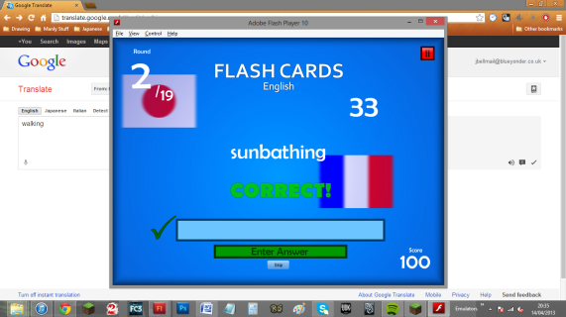

Evidence 6:

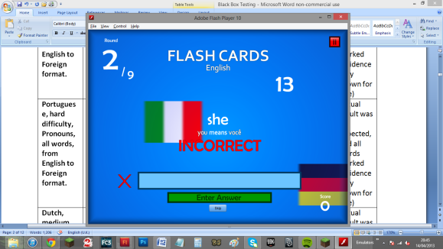

Evidence 7:

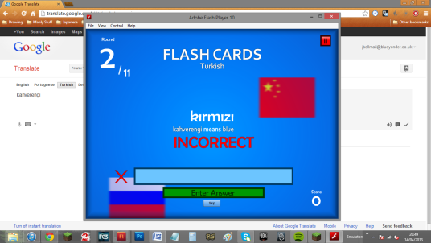

Evidence 8:

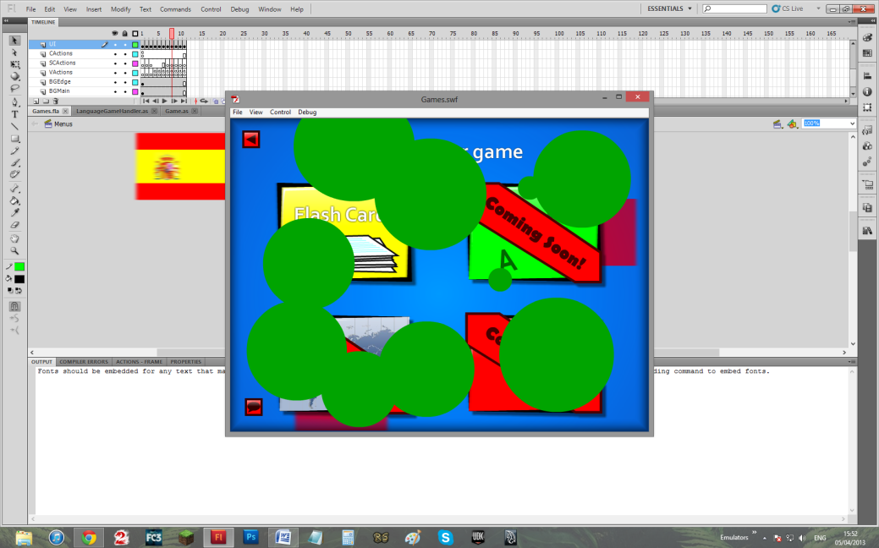

Evidence 9:

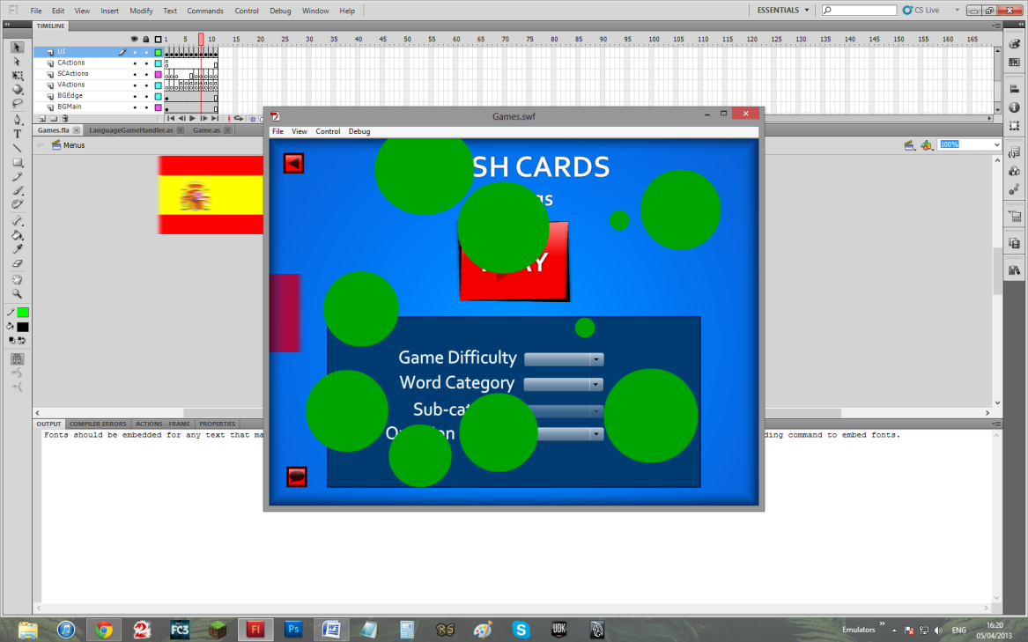

Evidence 10:

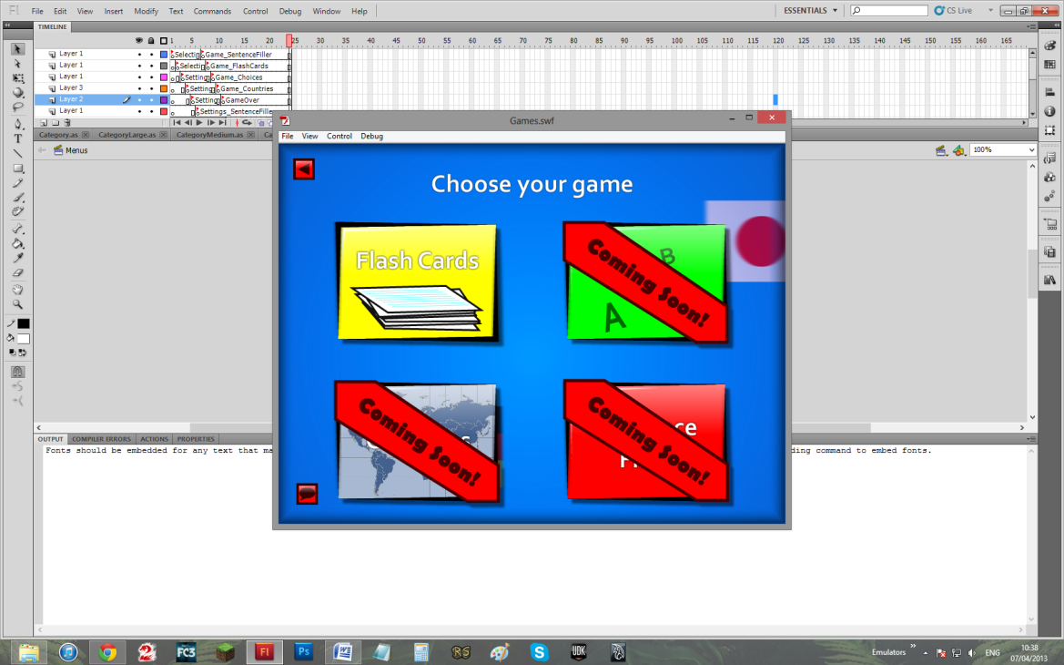

TO

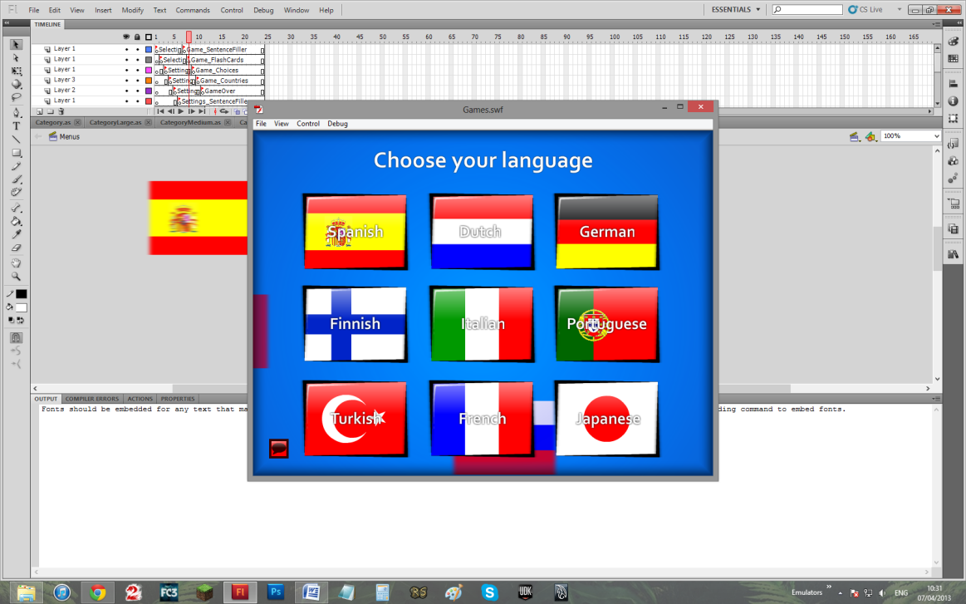

Evidence 11:

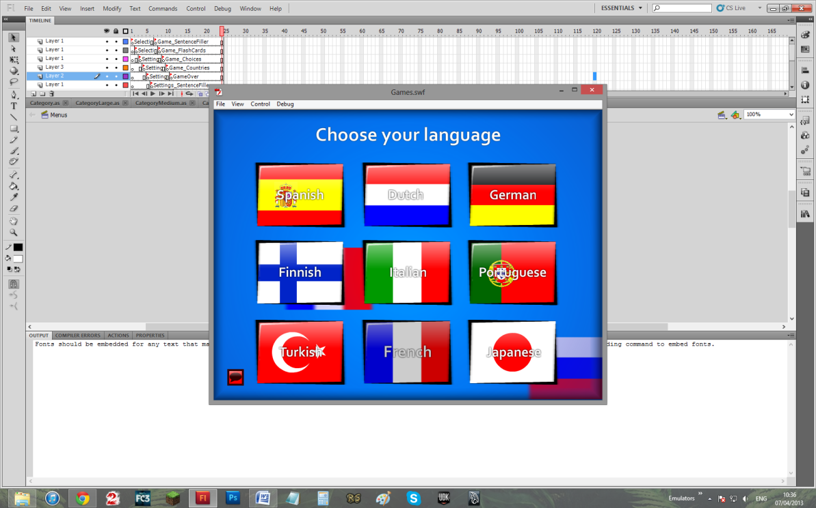

TO

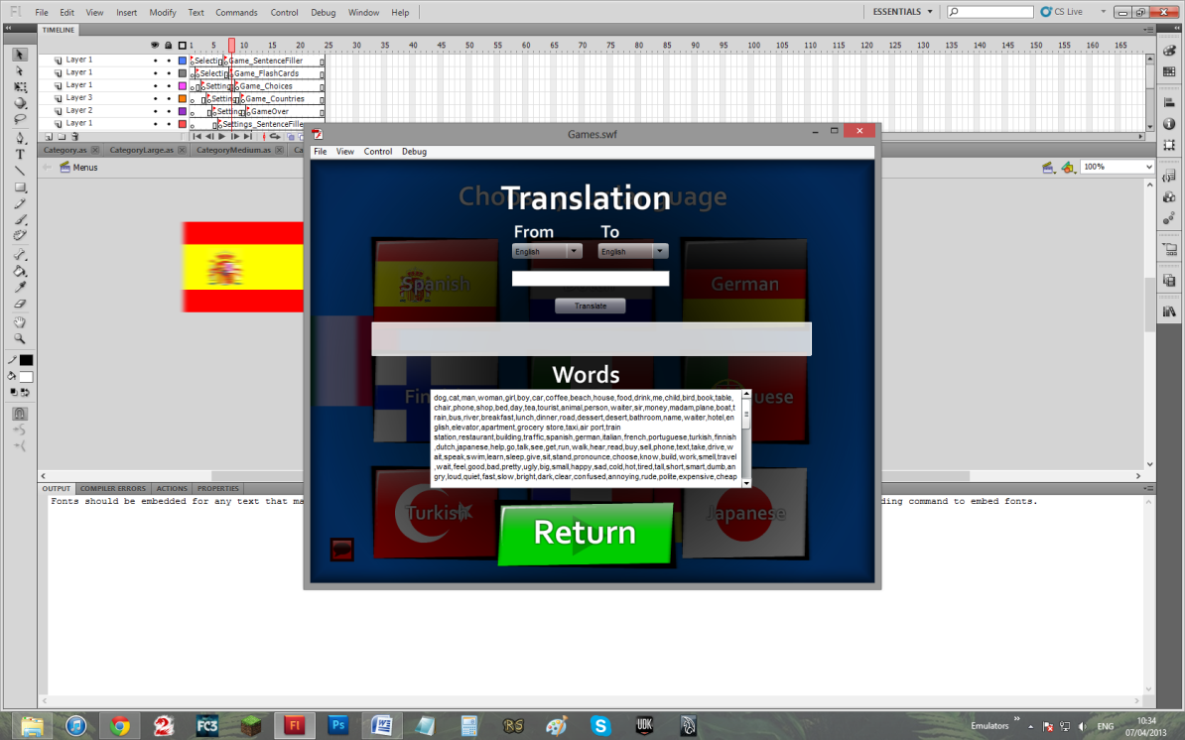

Evidence 12:



TO



Evidence 13:

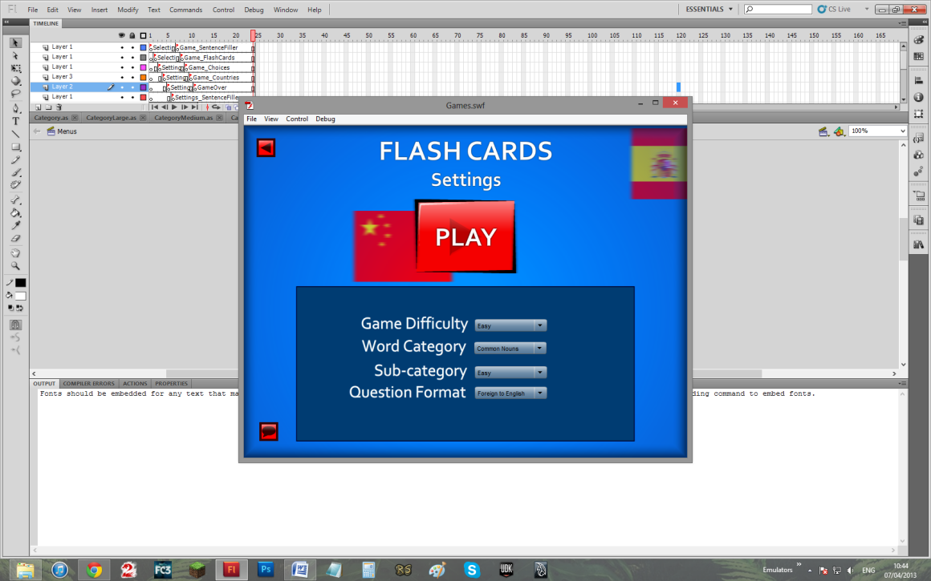

TO

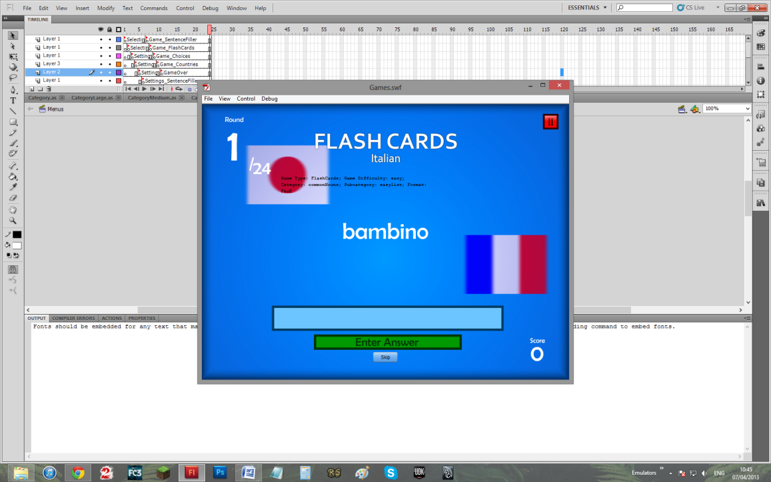

It is shown that the correct settings are in place (Note: these stats will **not** be shown in the final version)

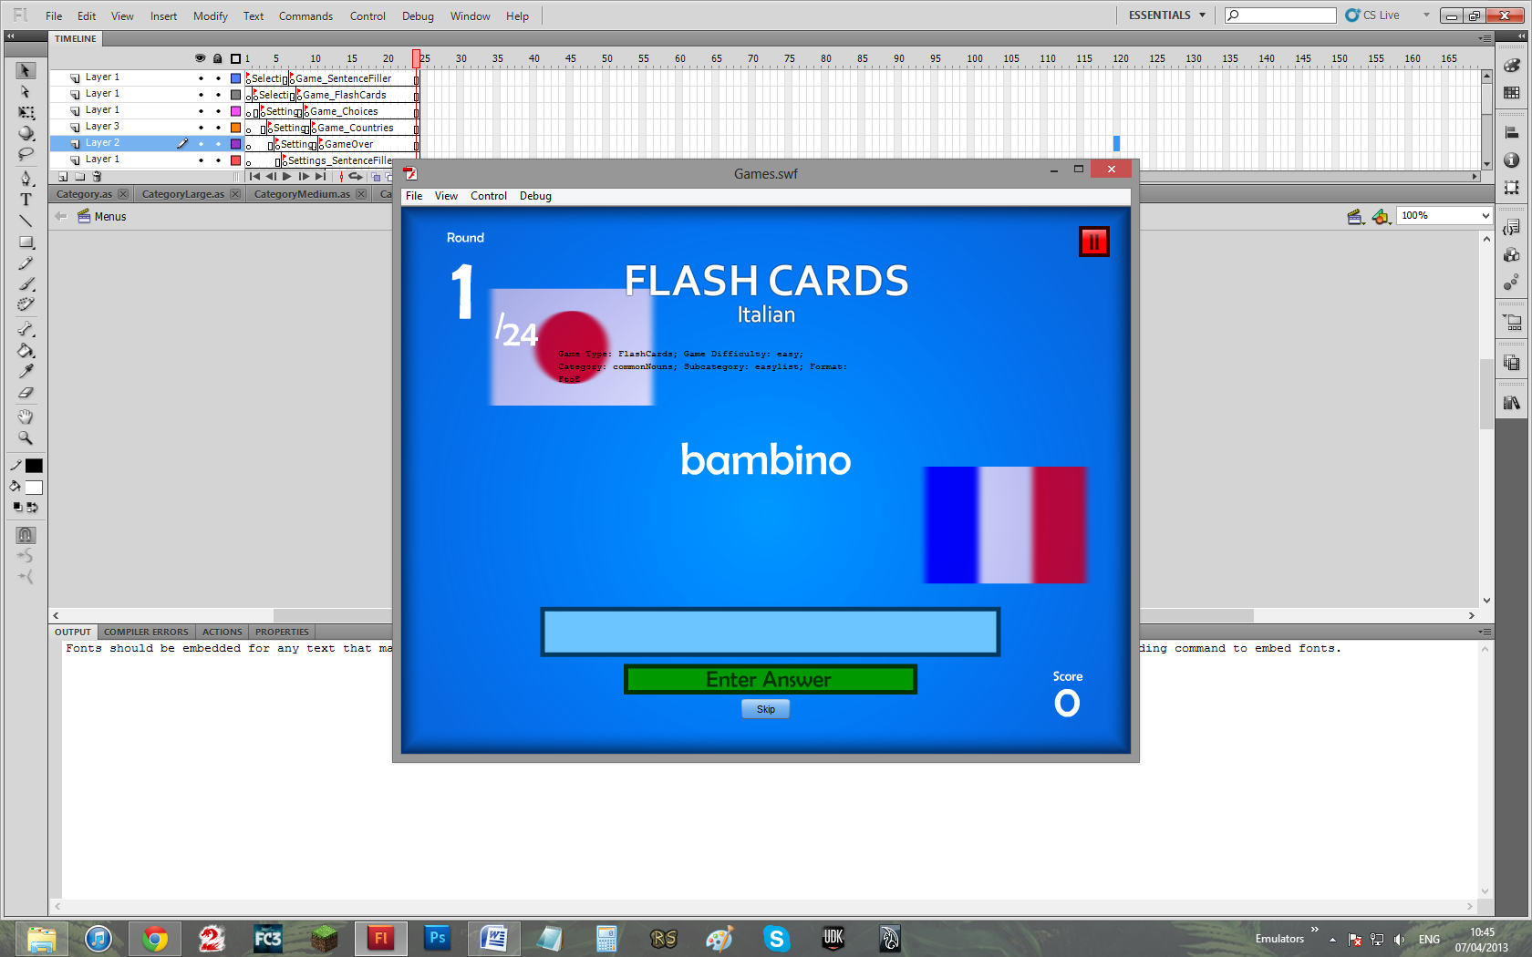

Evidence 14:

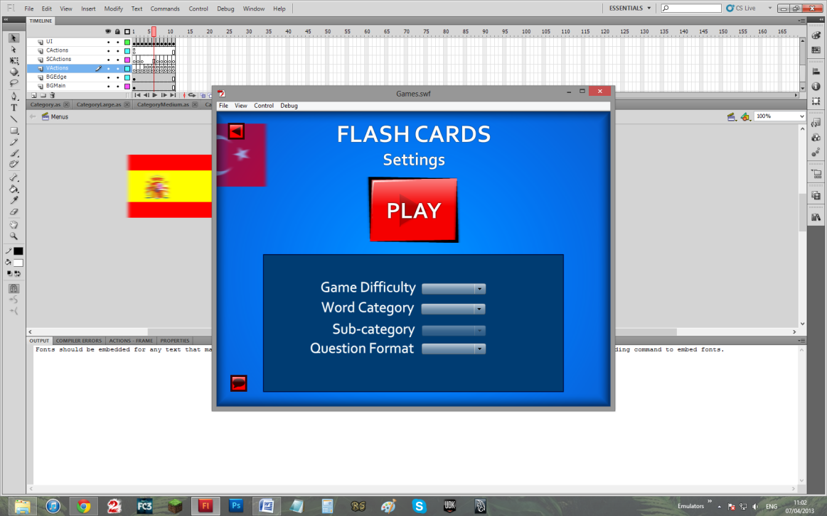

TO

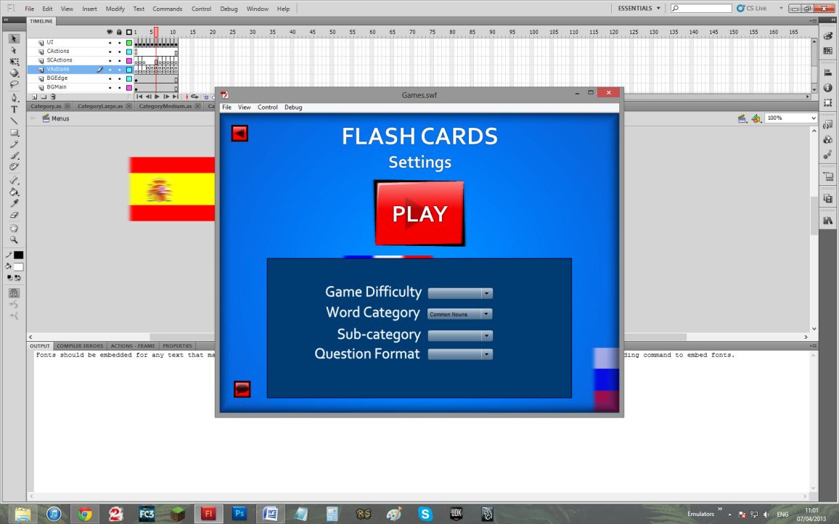

TO



Evidence 15:

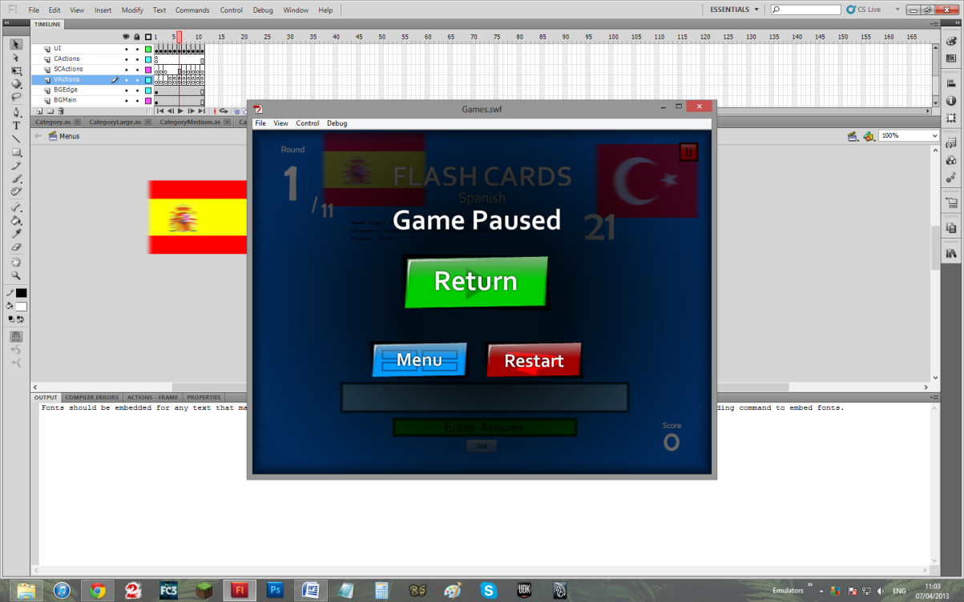

Evidence 16:

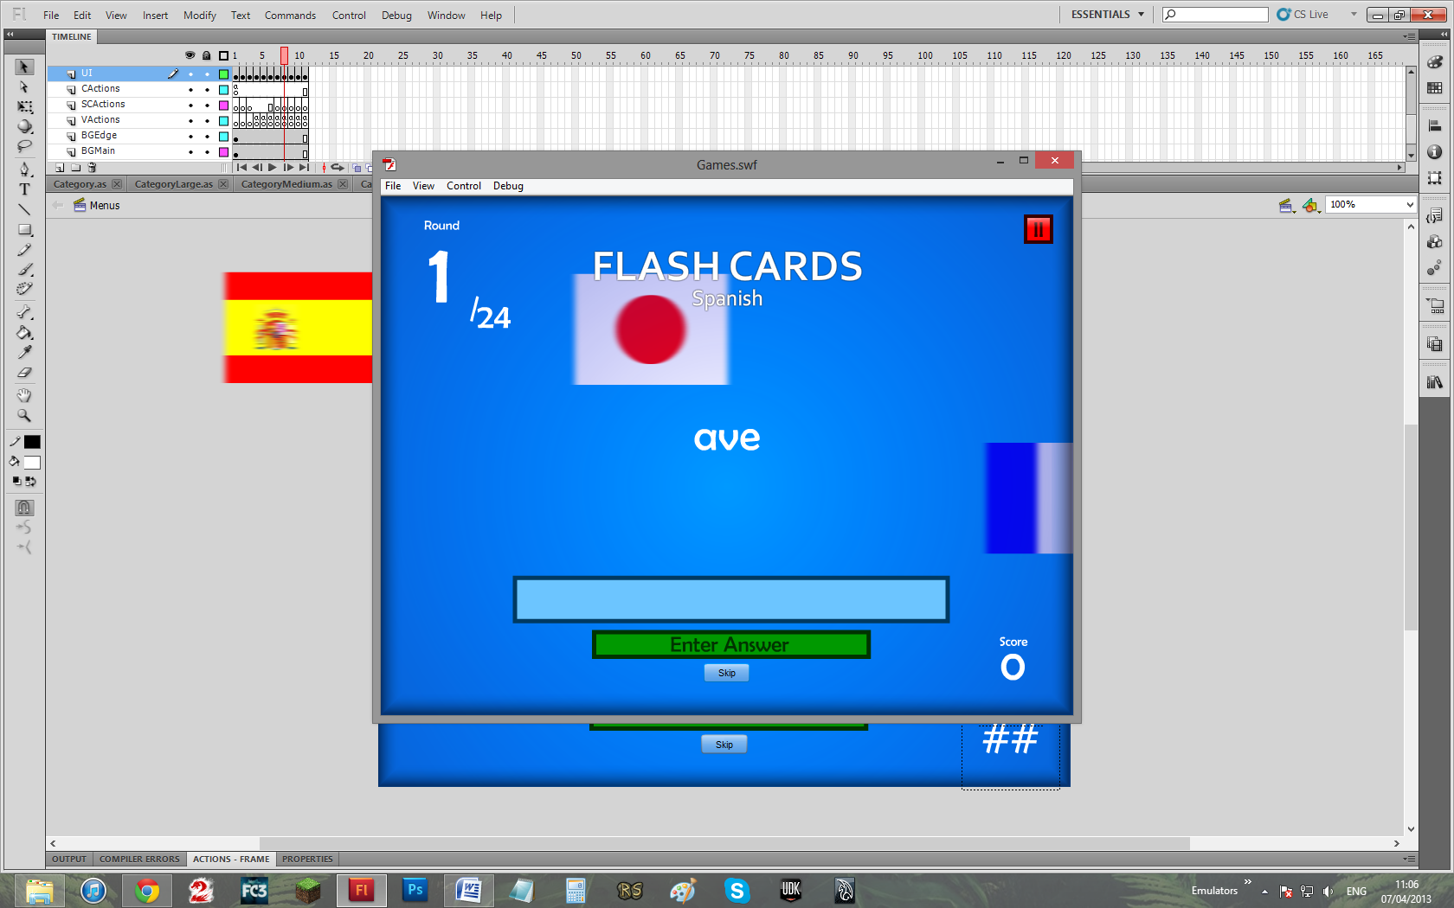

TO

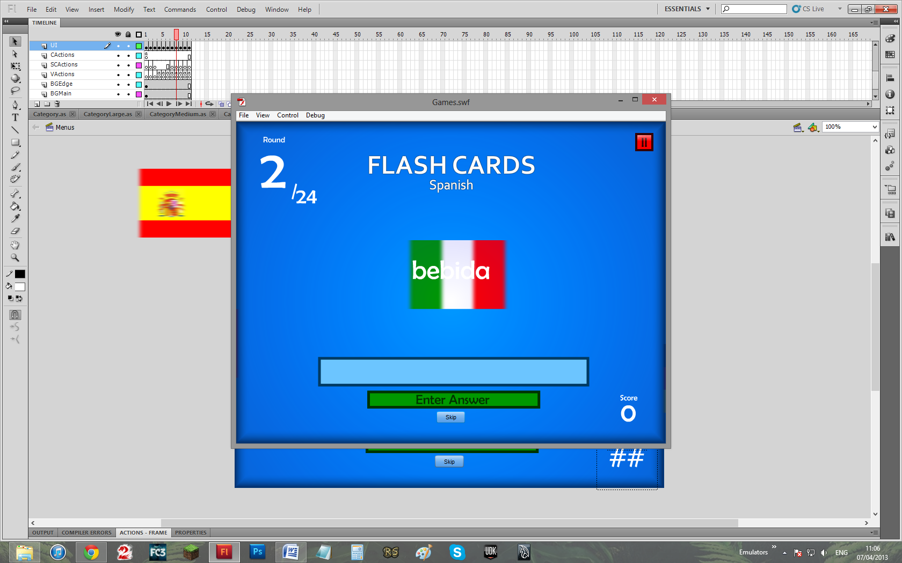

Evidence 17:

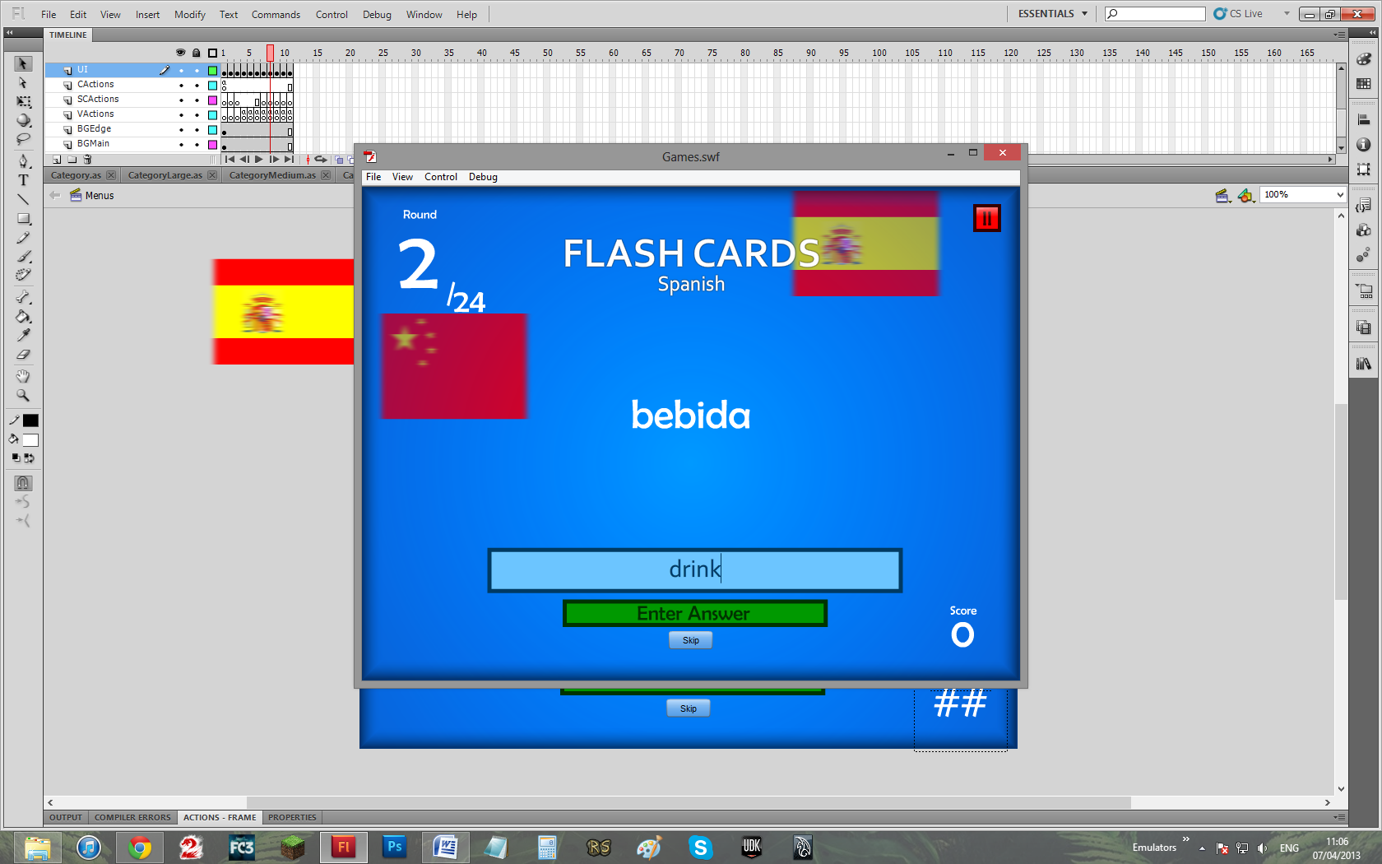

TO

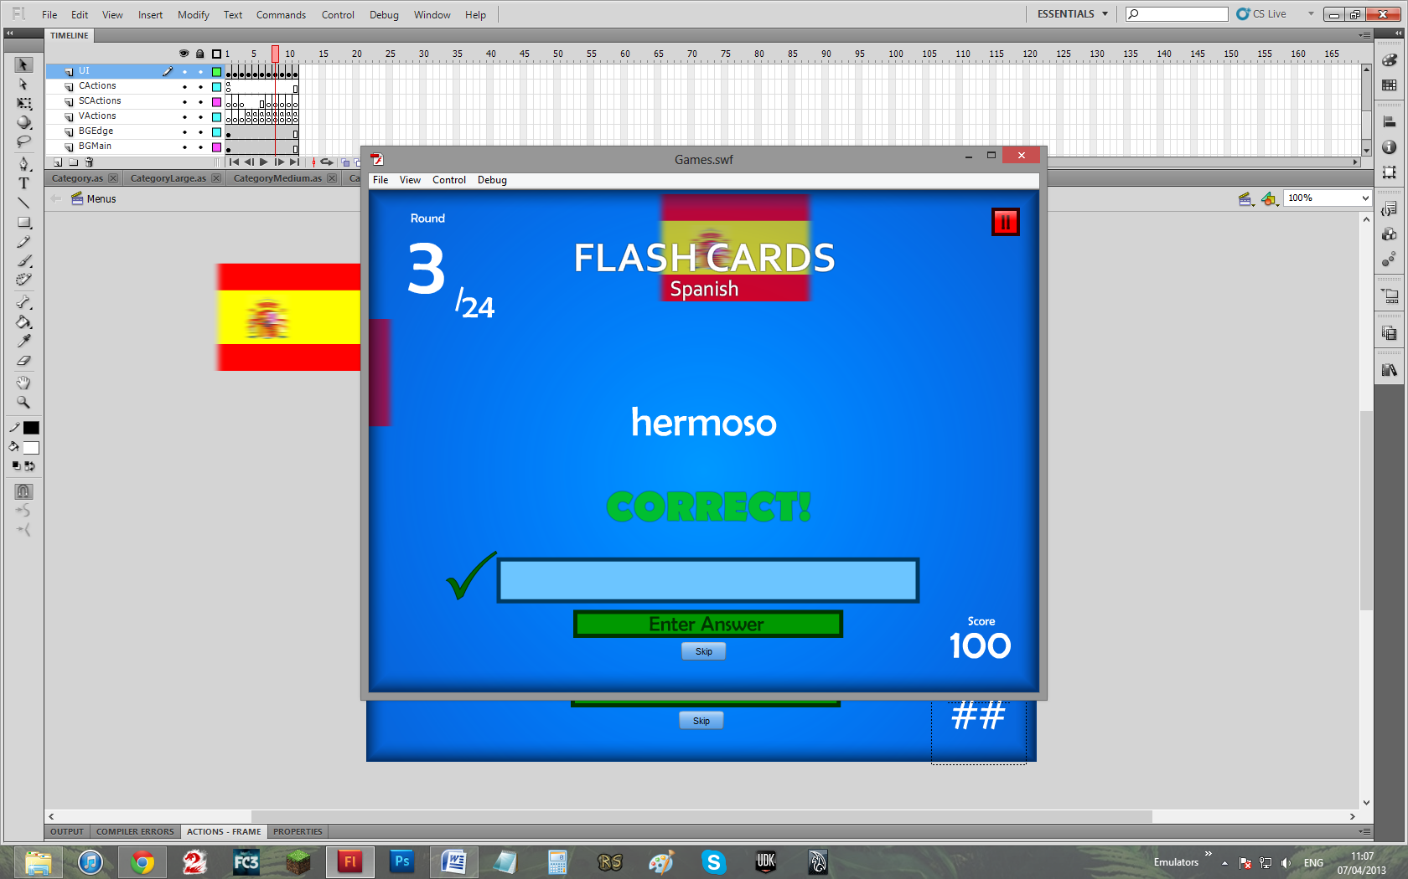

Evidence 18:

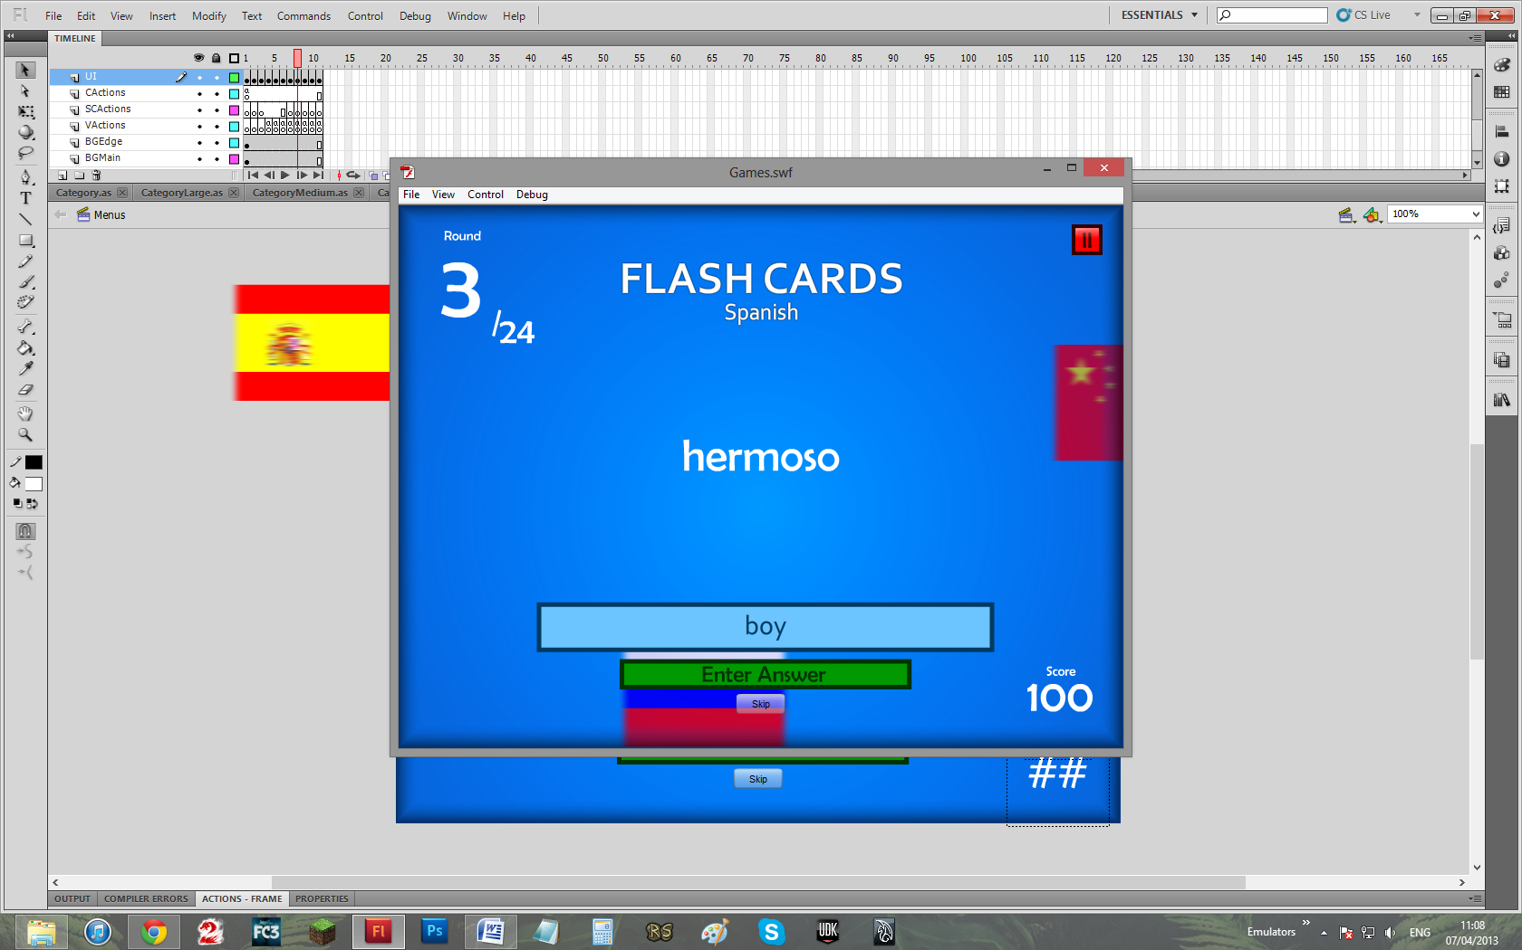

TO

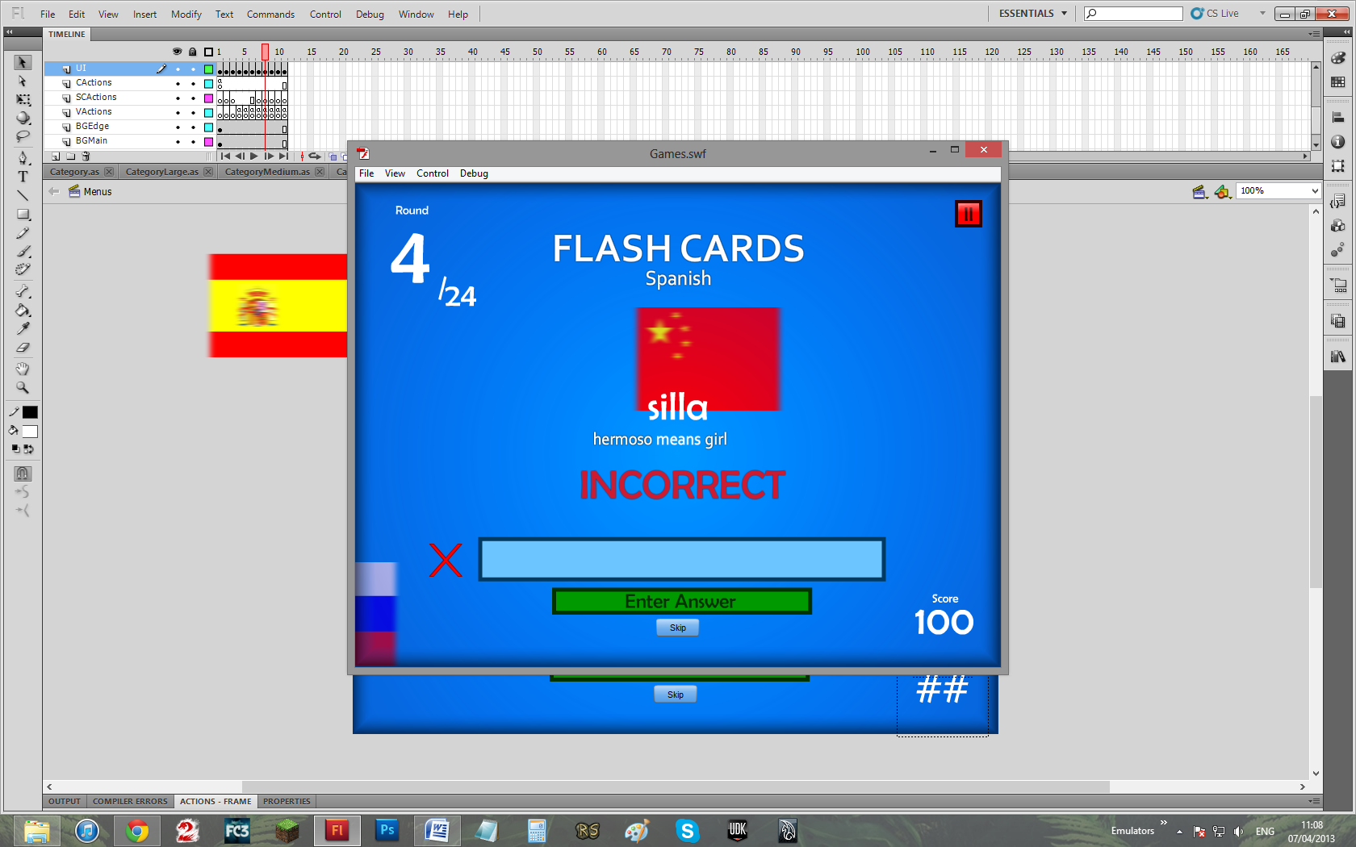

Evidence 19:

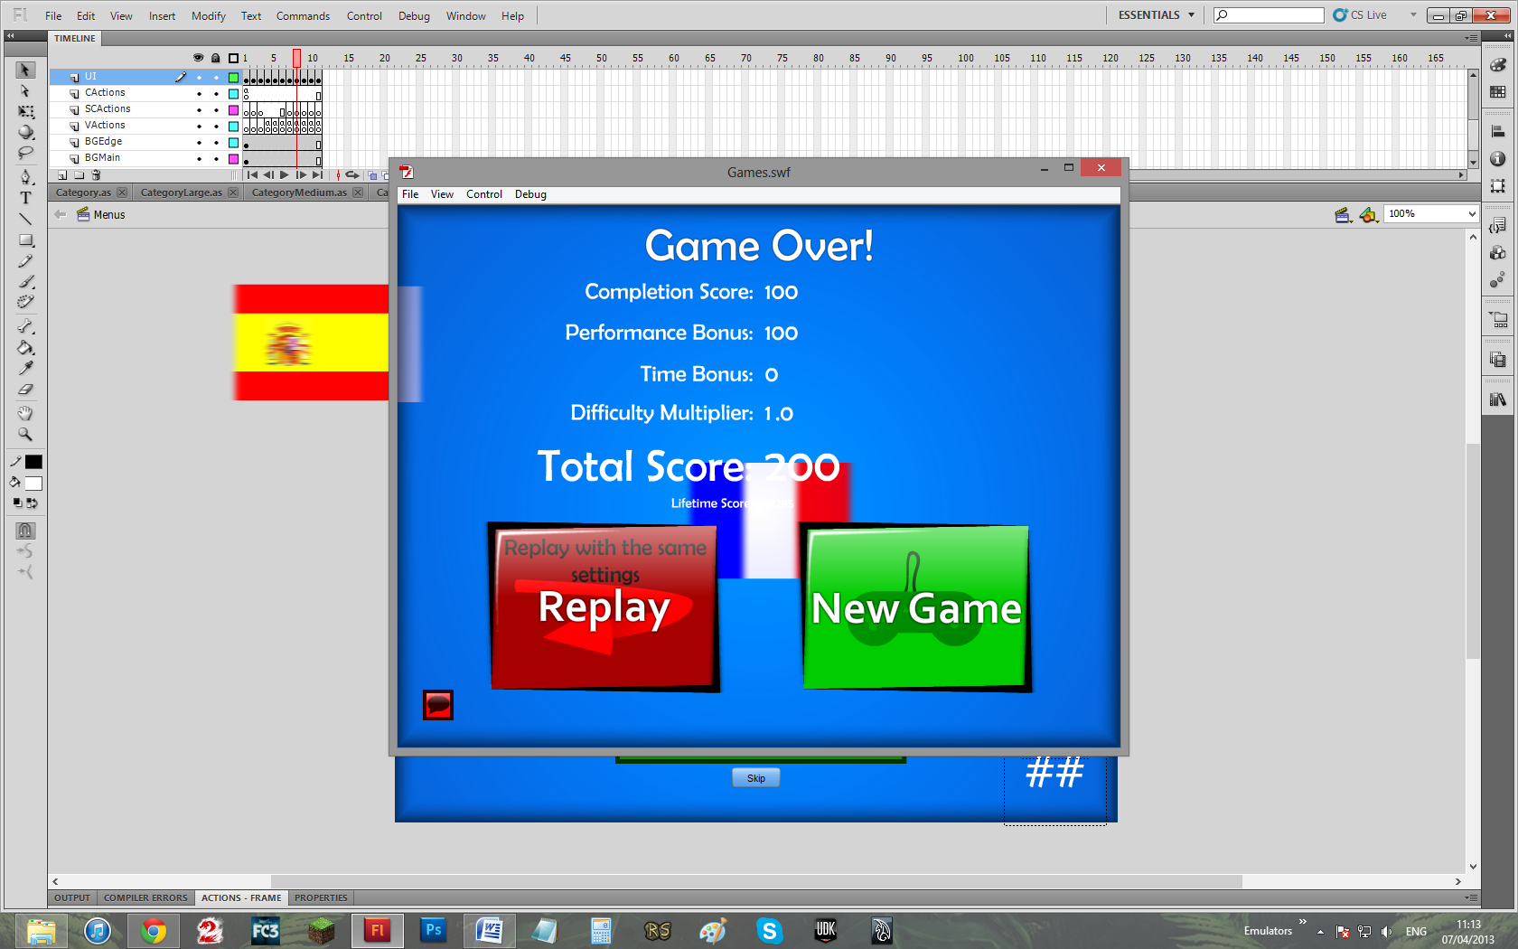

TO

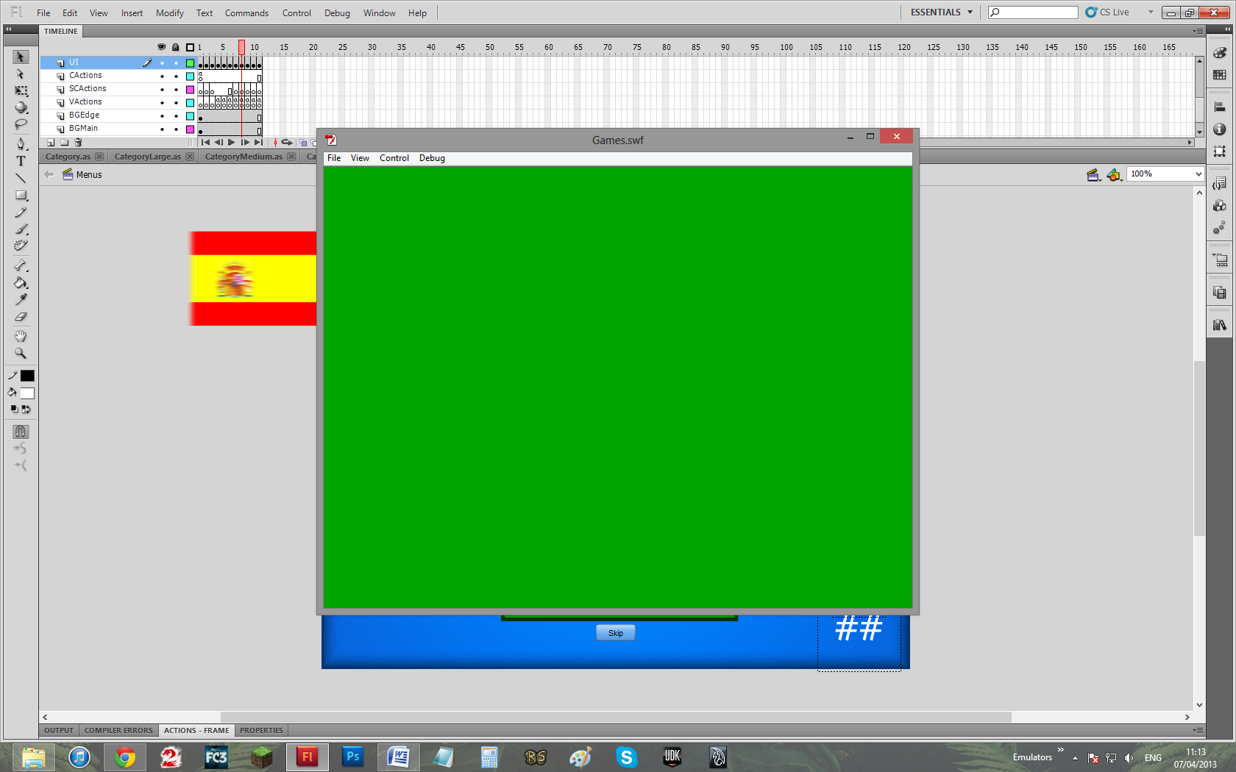

(transition)

TO

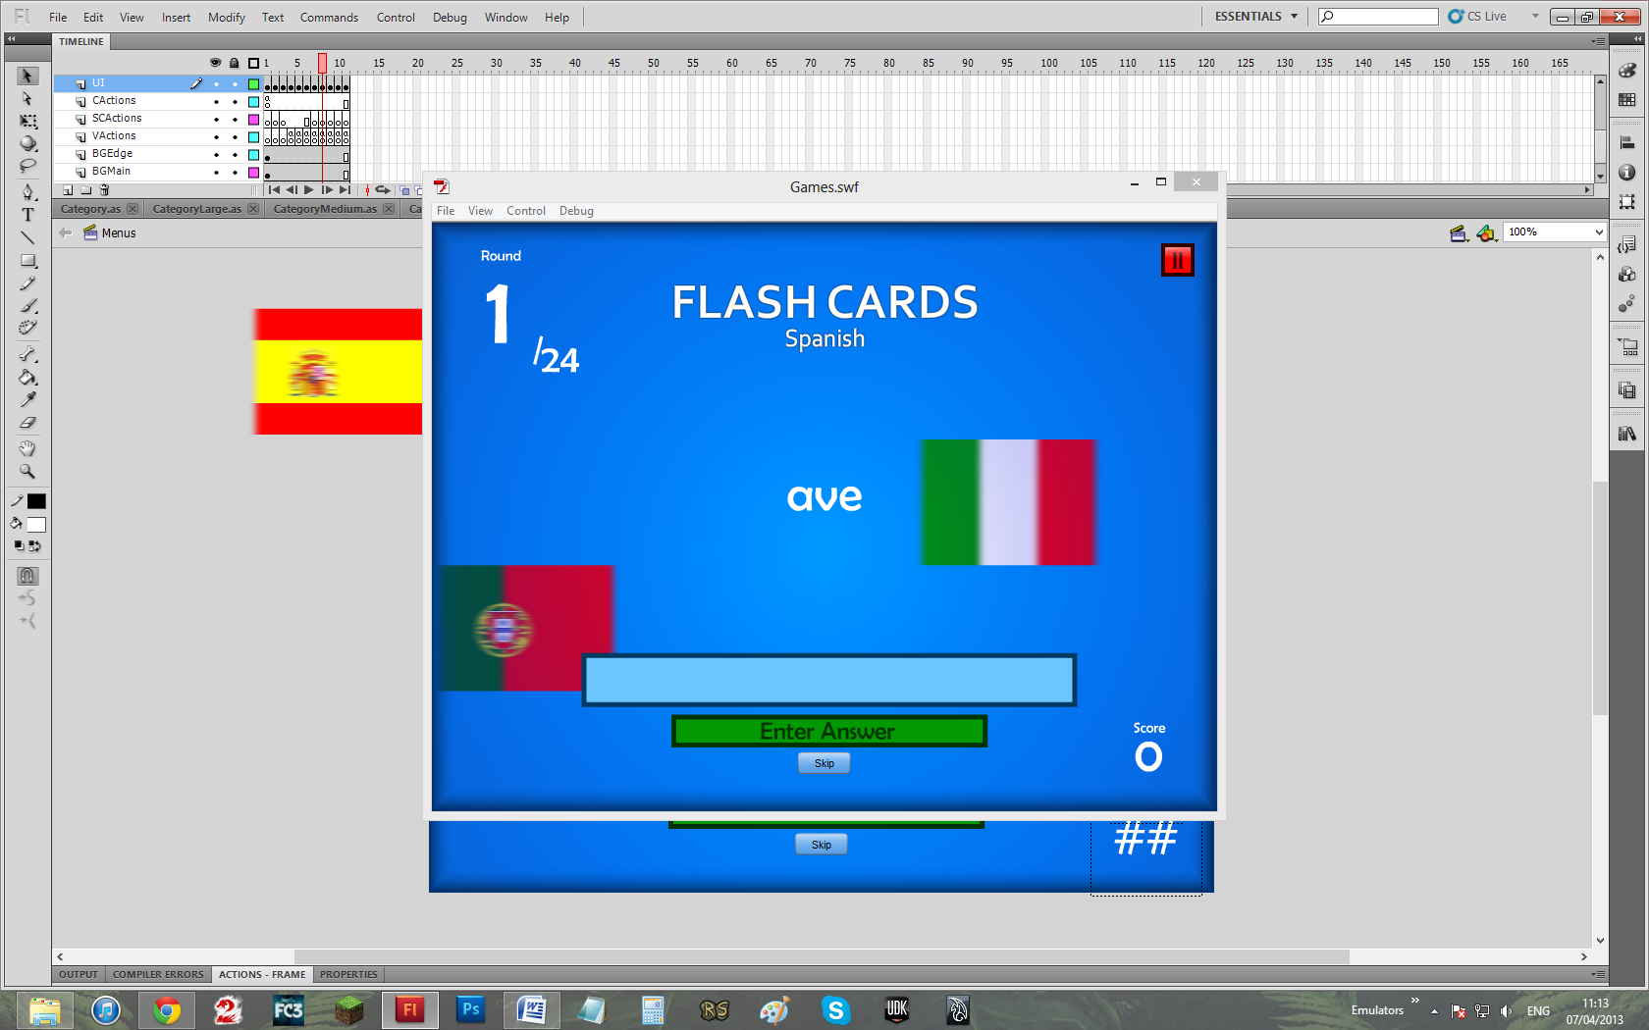

Evidence 20:

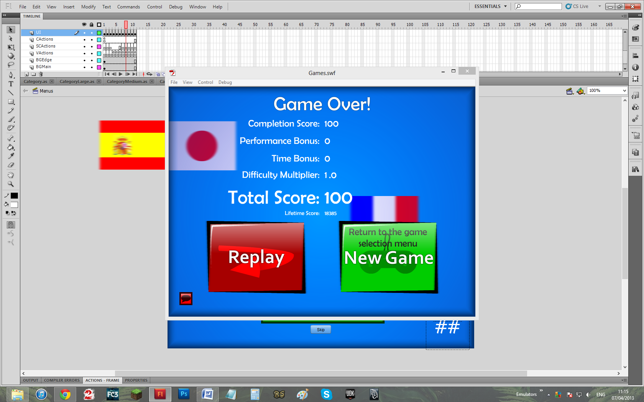

TO

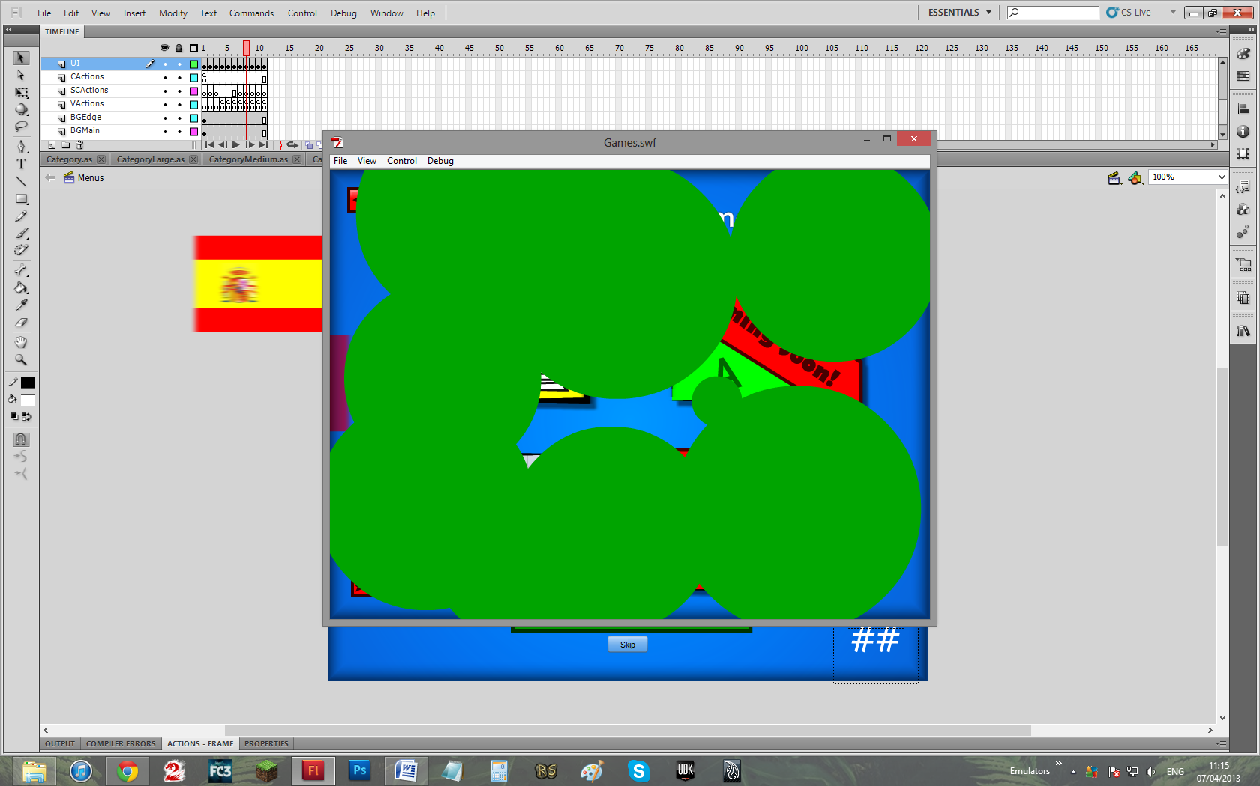

(transition)

TO

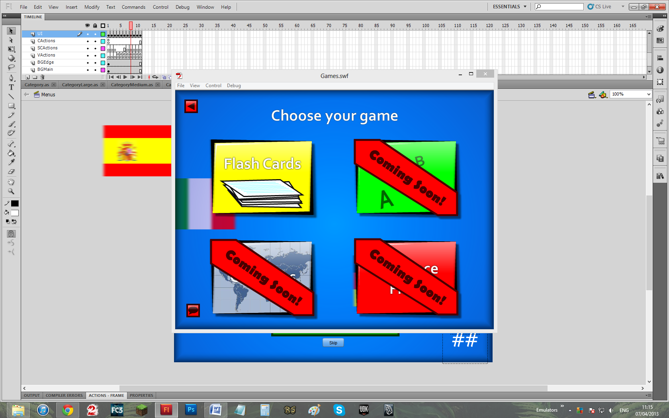

Evidence 21:

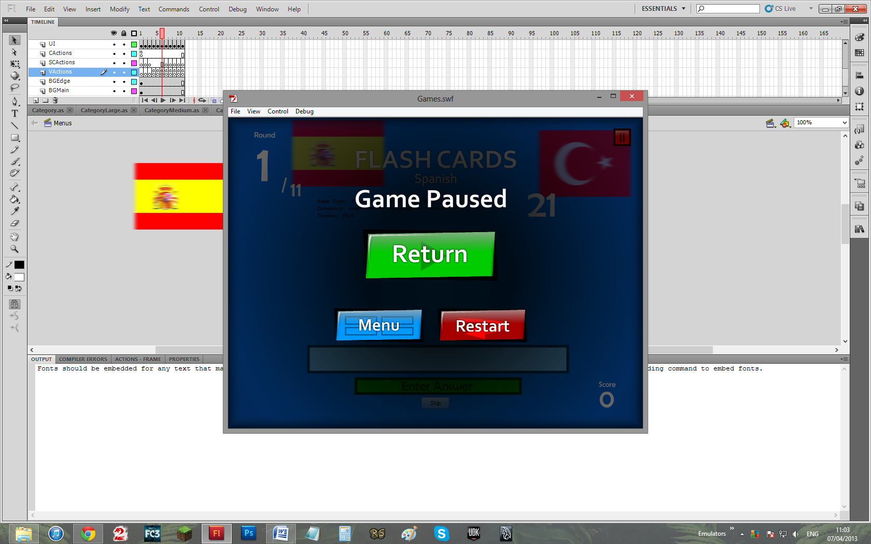

TO

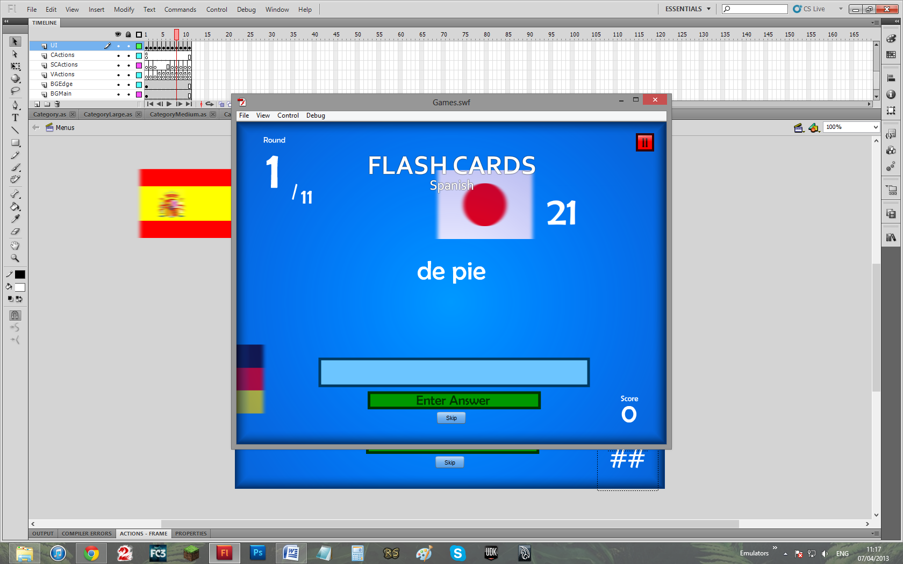

Evidence 22:

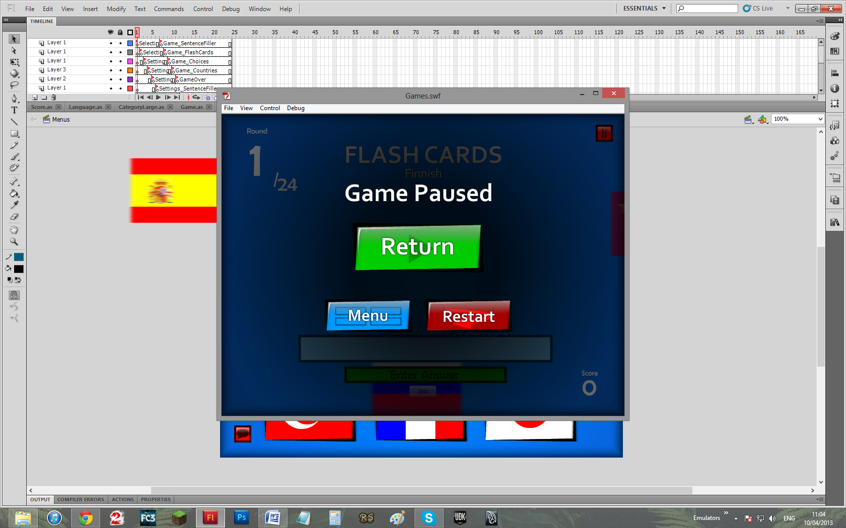

TO

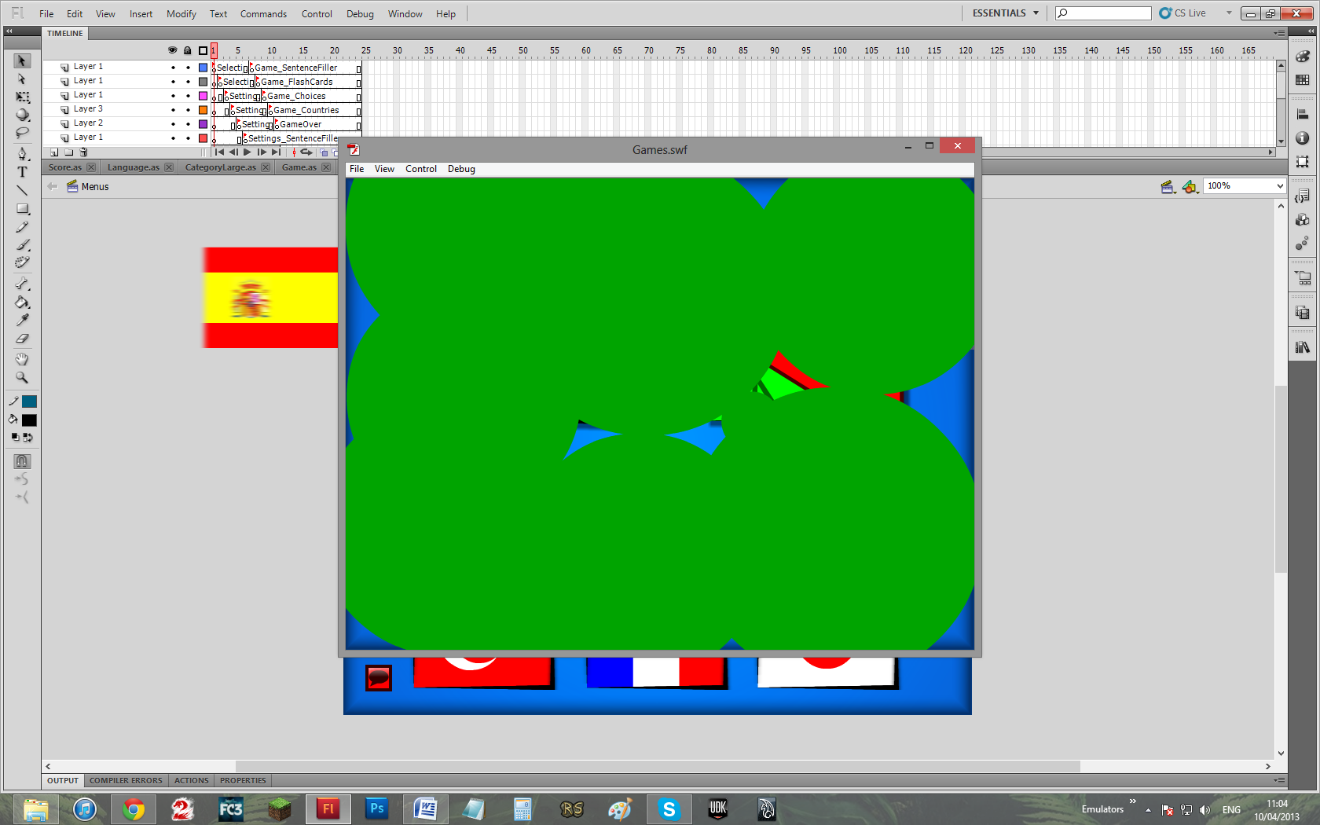

(transition)

TO

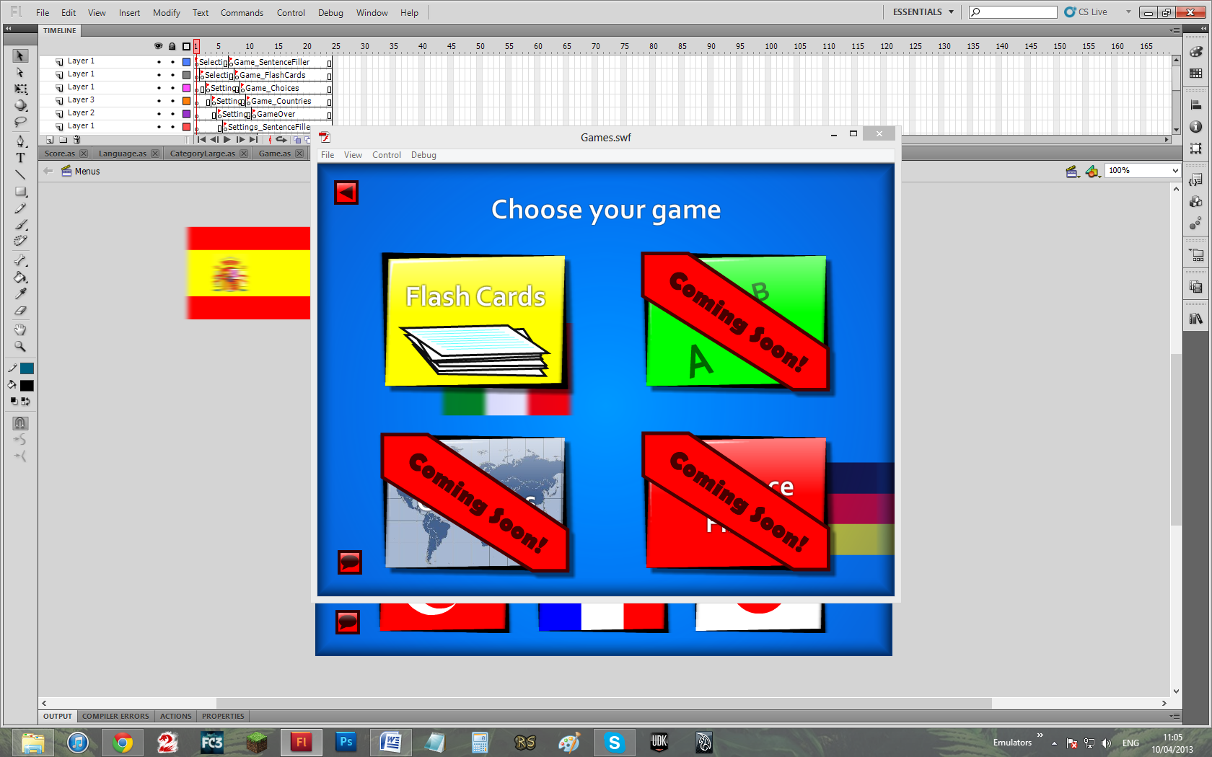

Evidence 23:

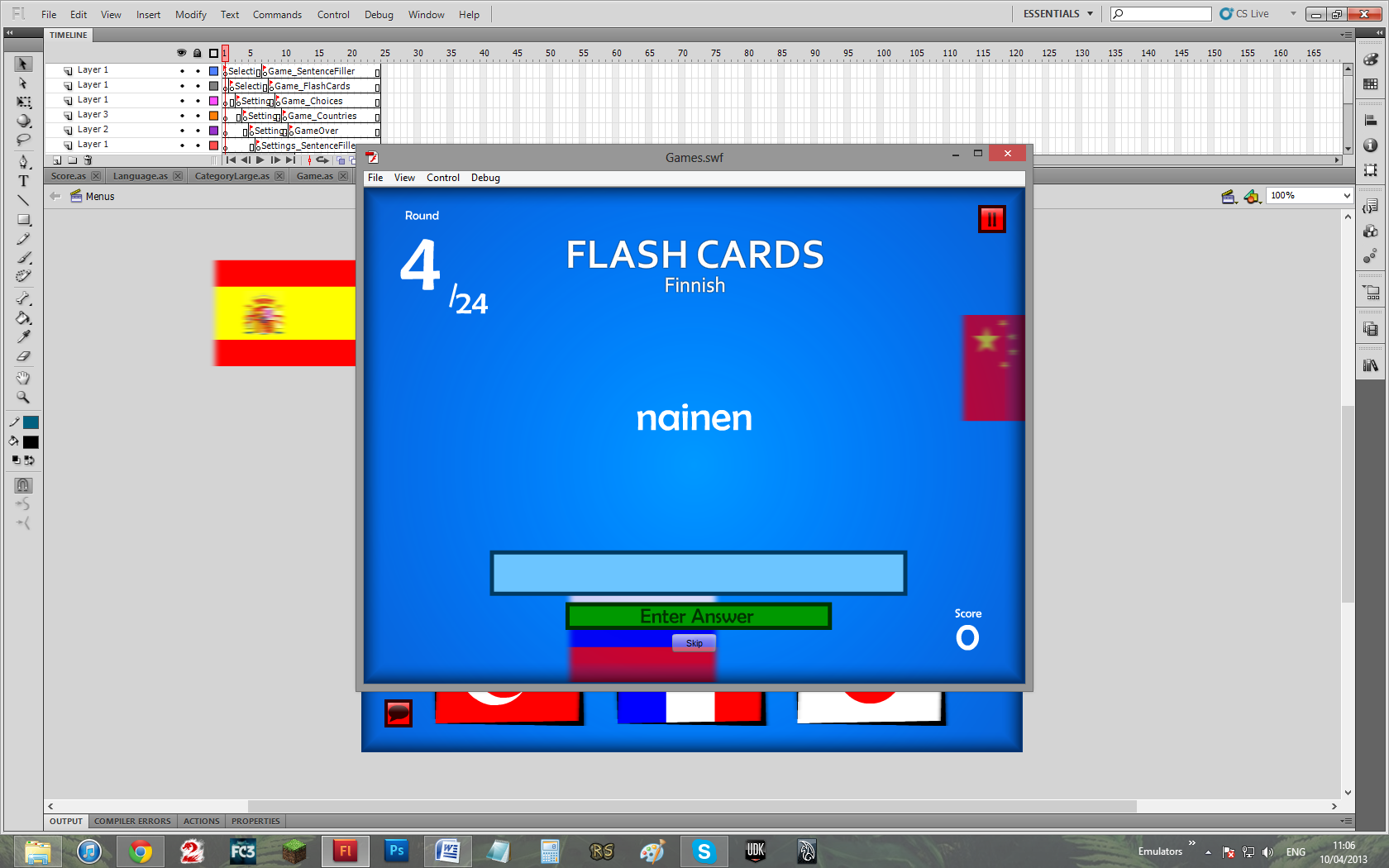

TO

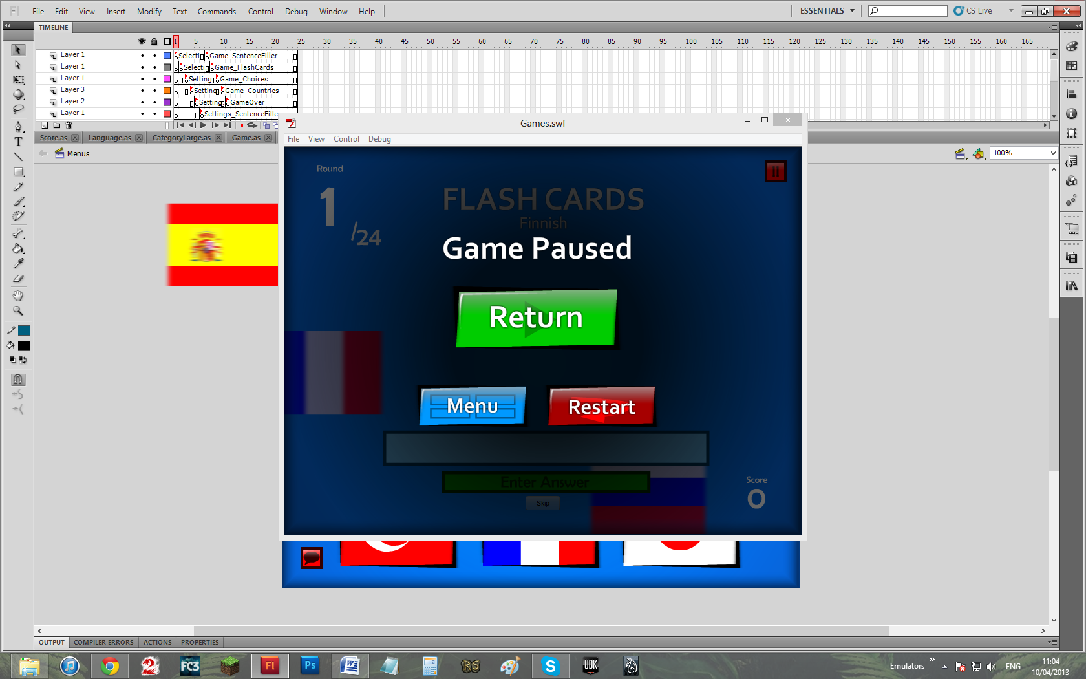

TO

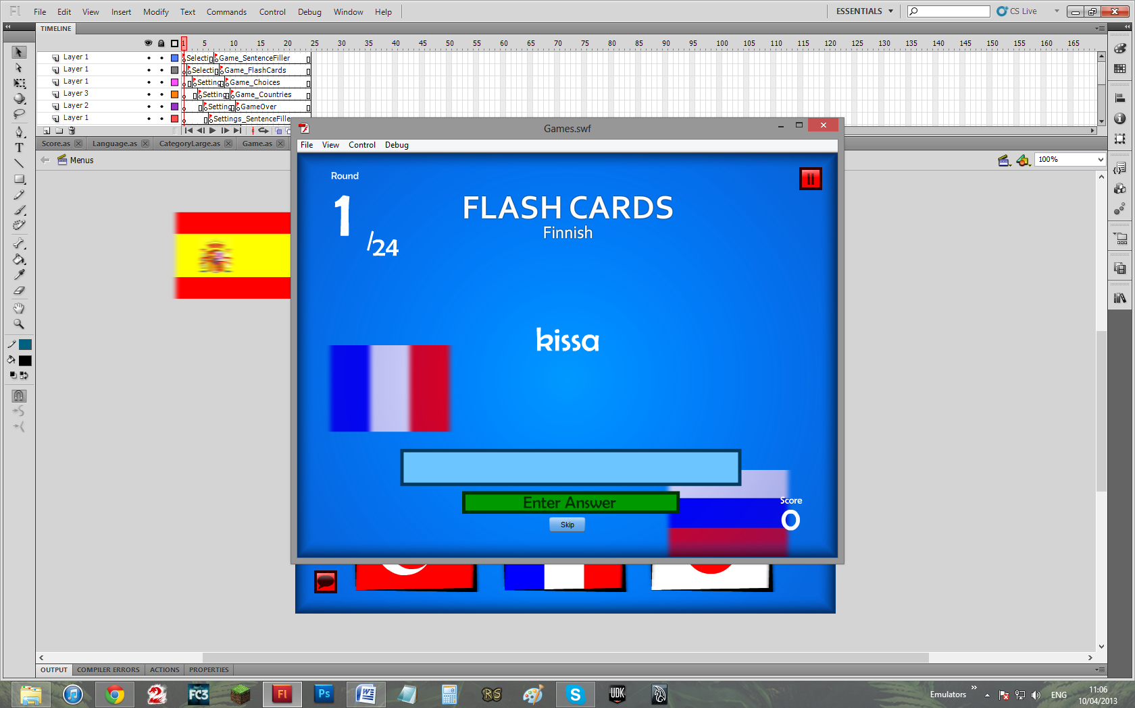

Evidence 24:

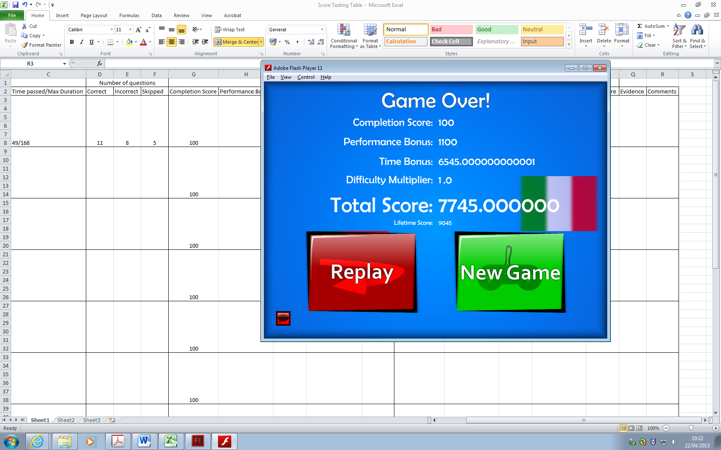

Evidence 25:

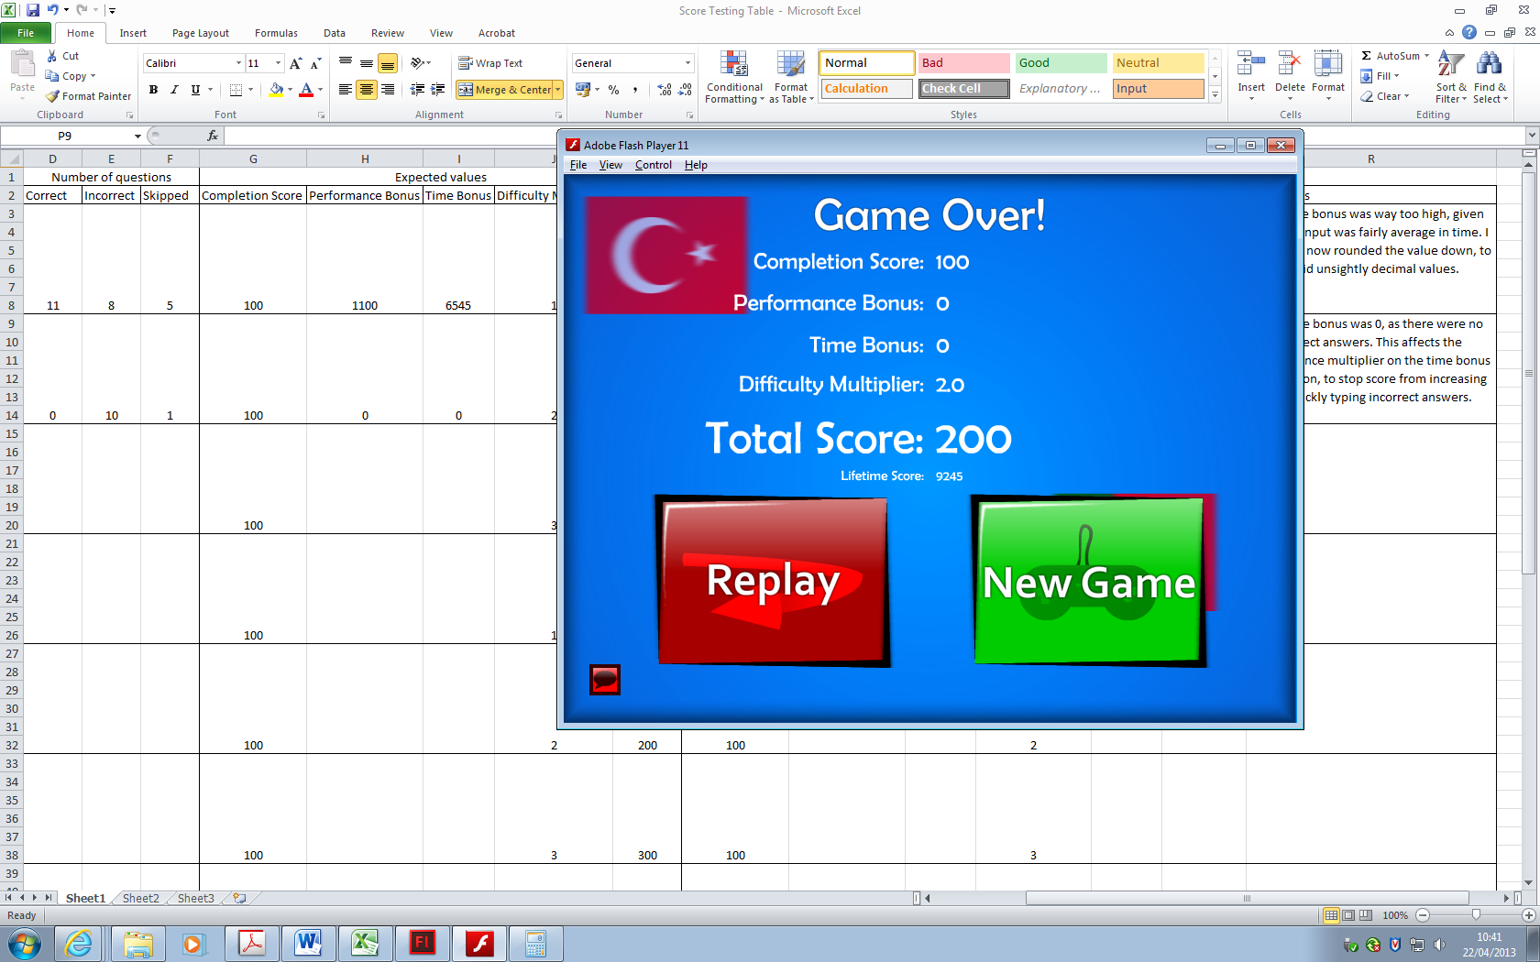

Evidence 26:

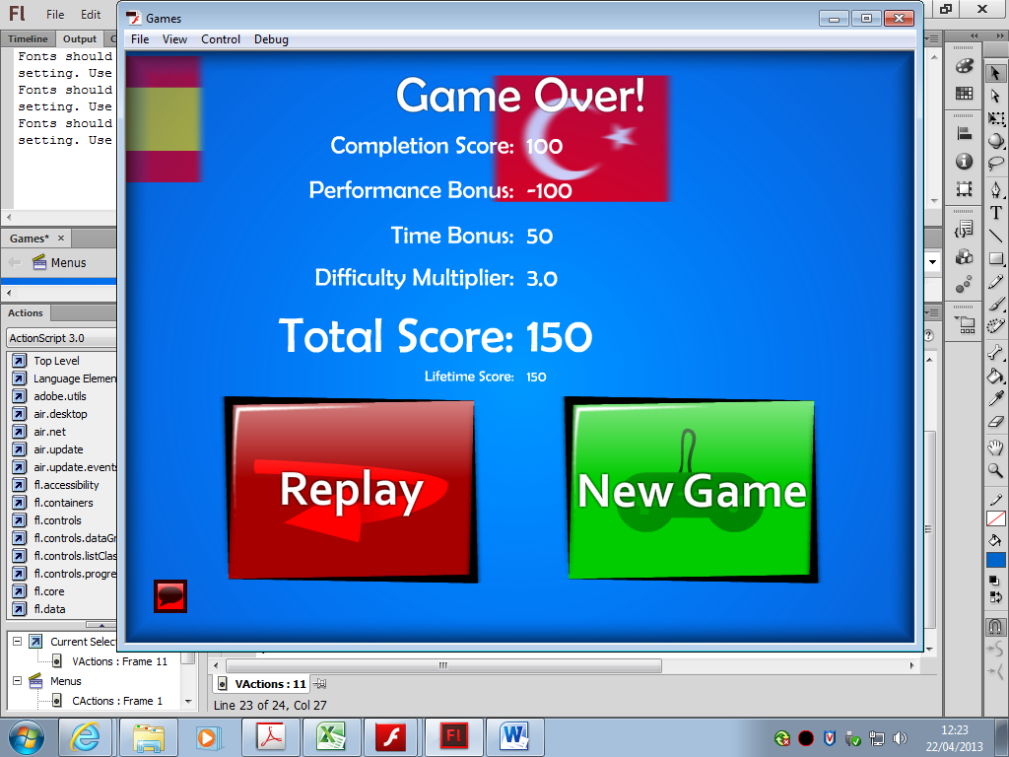

Evidence 27:

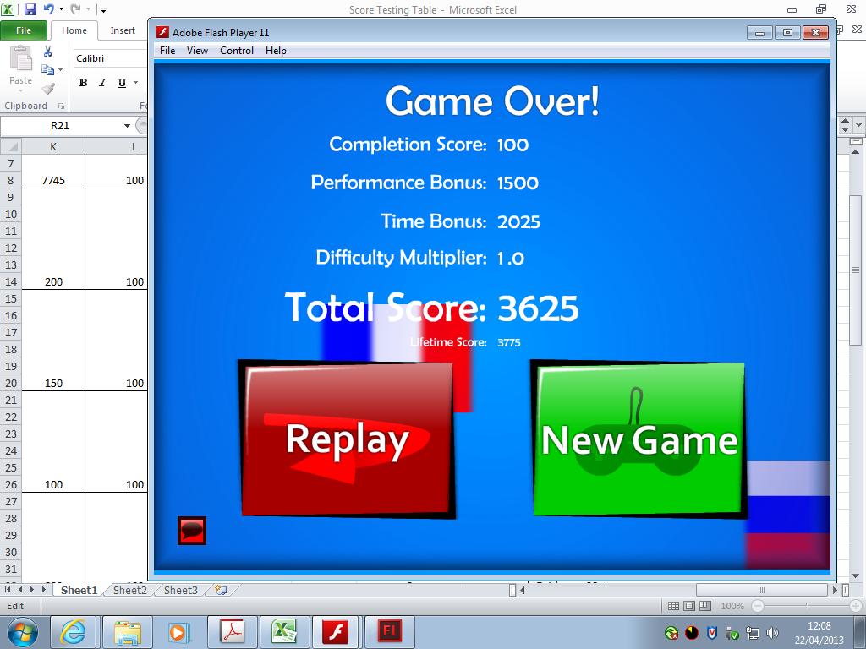

Evidence 28:

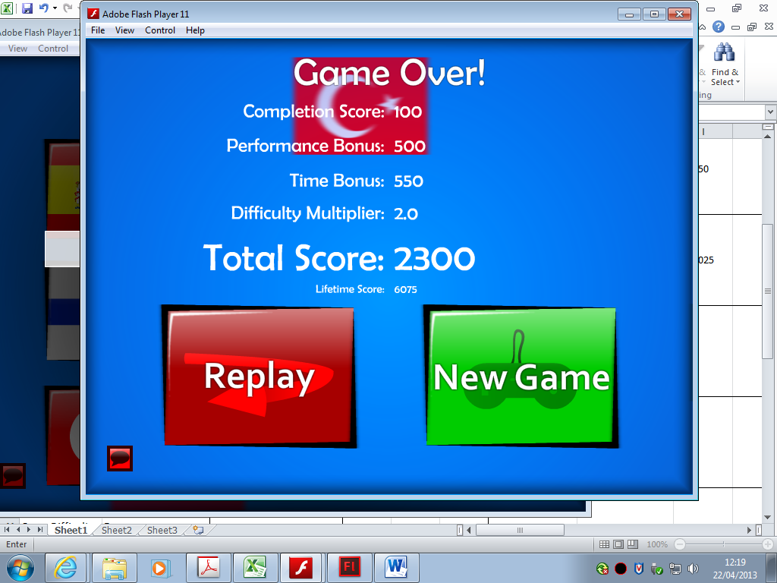

Evidence 29:

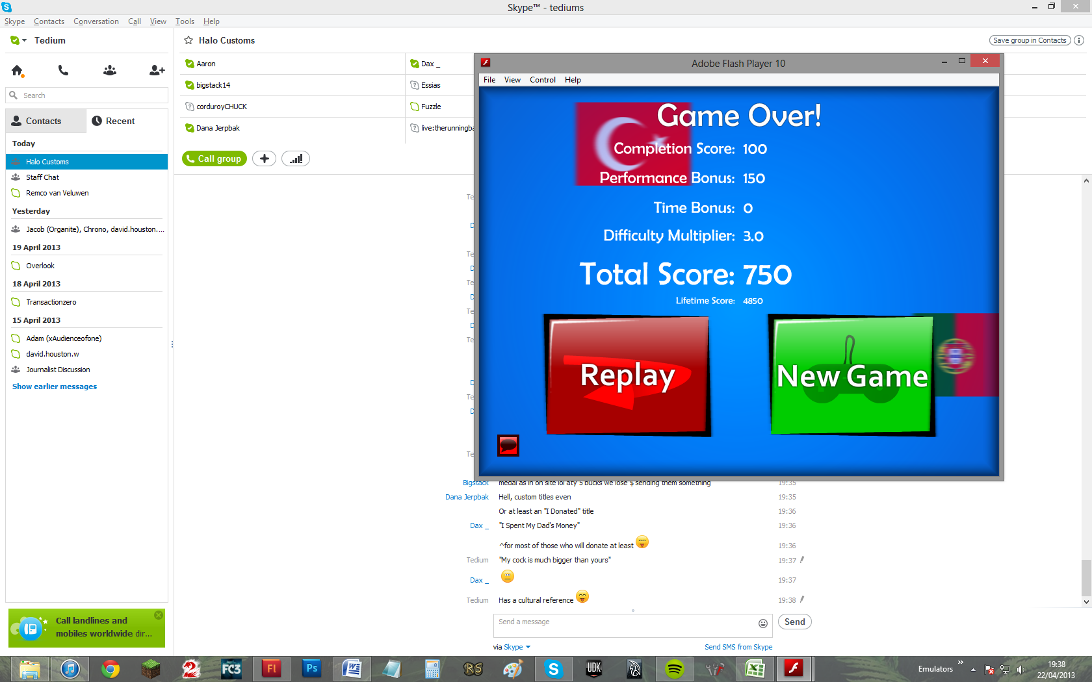

Evidence 30:

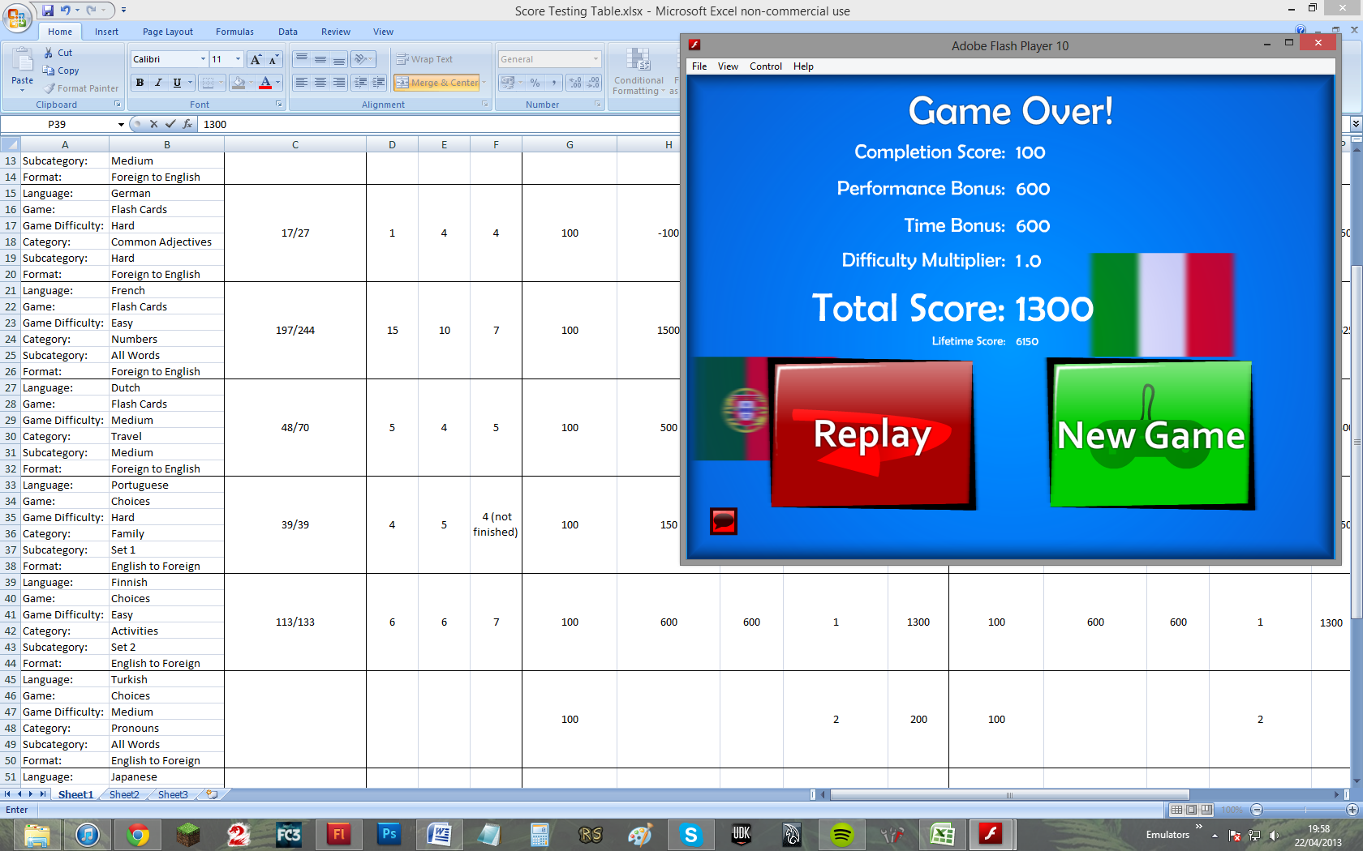

Evidence 31:

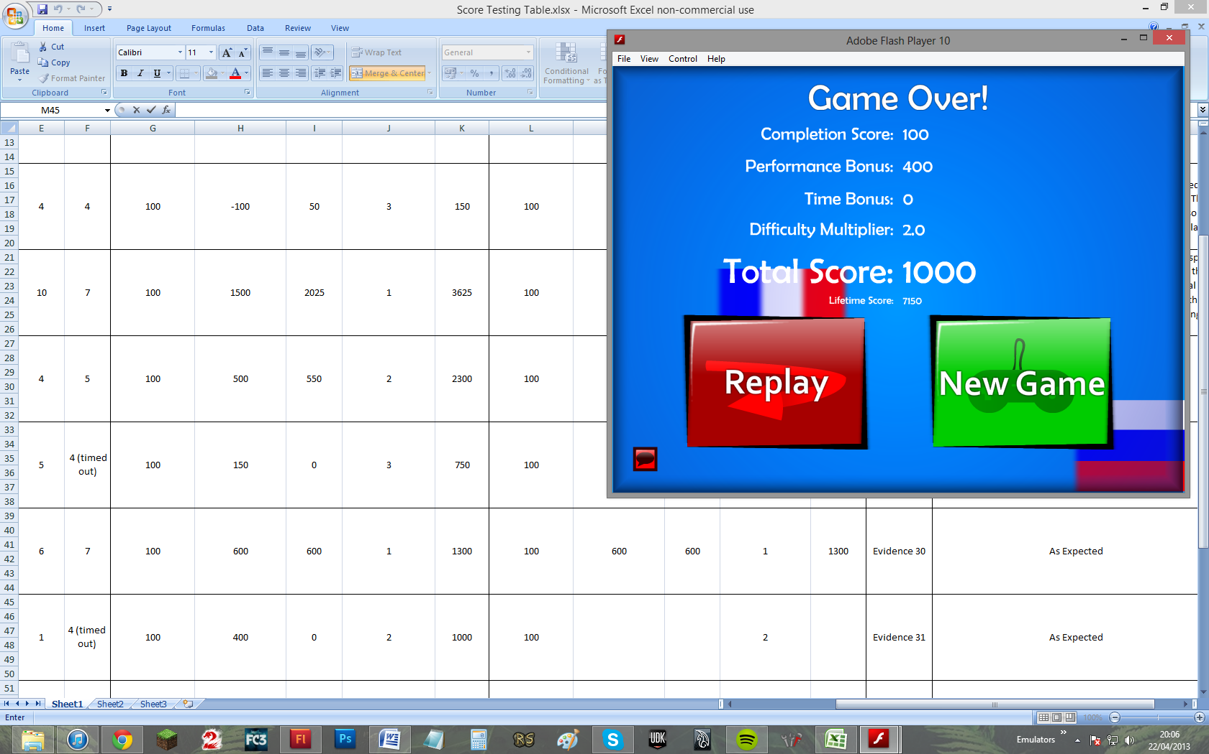

Evidence 32:

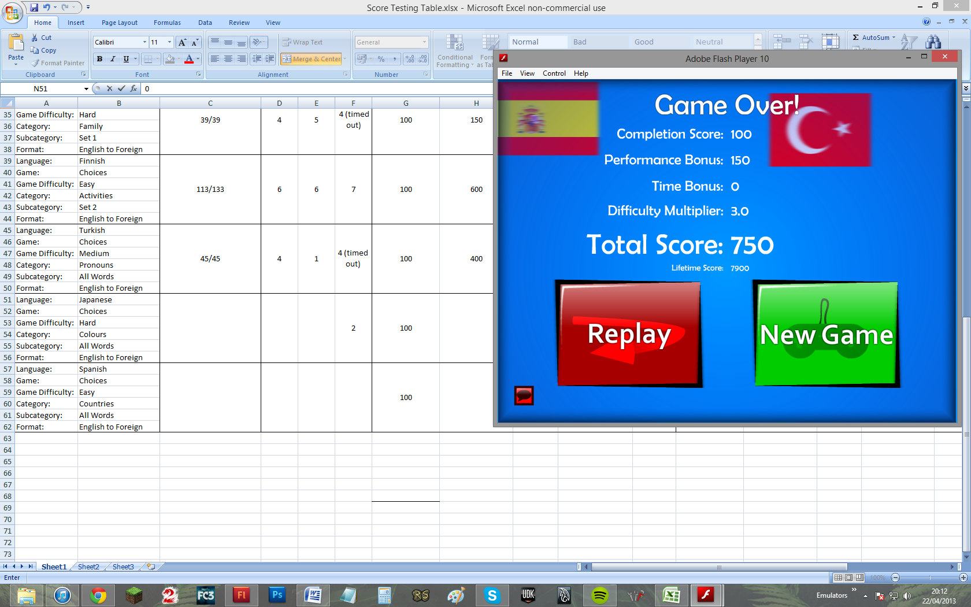

Evidence 33:

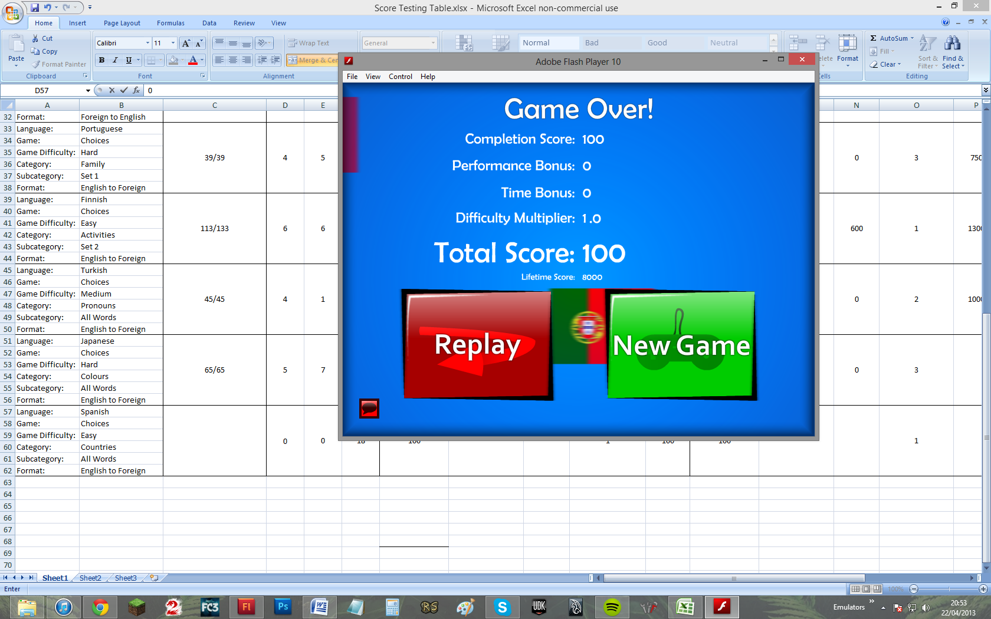

Evidence 34:

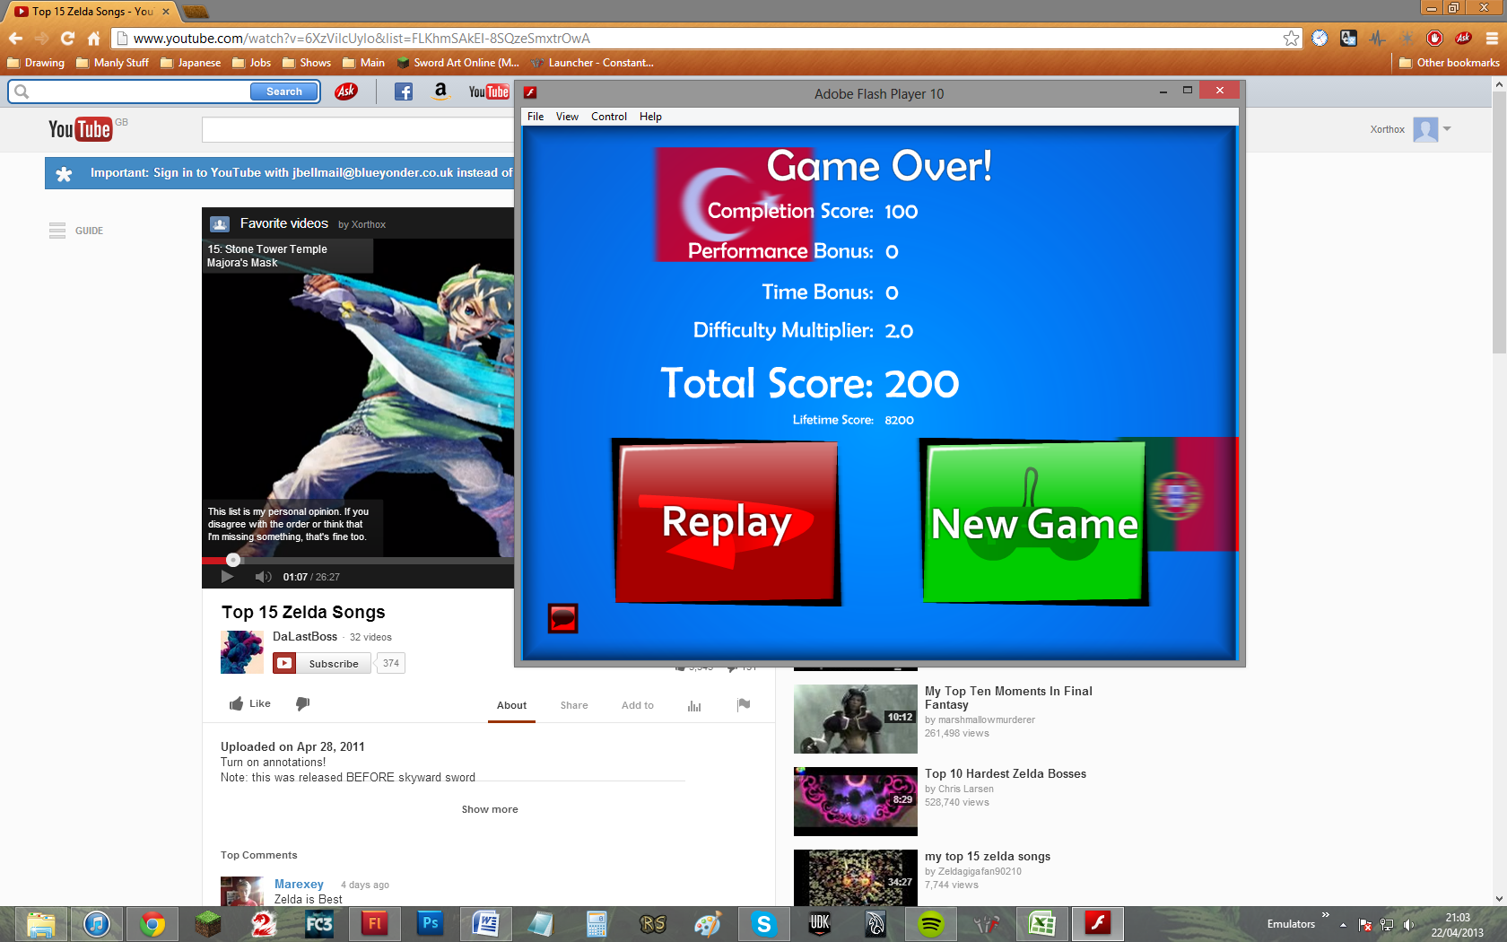

Evidence 35:

